INVENTORY MAKE AND CHECK-IN REPORT

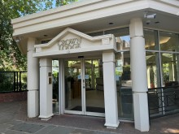
SAMPLE
Instructing Party: LCP |  | Conducted by: Perfect Inventories
Perfect Inventories
perfectinventories@gmail.com
Tel: 07464709201
Date | Time | Bedrooms | Extra Areas
SAMPLE | 10.30am | 1 | None



Whilst every care is taken to ensure the accuracy of this inventory, it is strongly advised that the accuracy of this report lies with the Landlord, Tenant and/or any other involved party or instructing principle and that any queries or discrepancies relating to the description or content be addressed to Perfect Inventories – perfectinven@gmail.comwithin 7 days of an receipt. This report should be thoroughly checked. If we do not hear from you within this period in writing, we can assume that this report is an accurate representation of the condition of the property. Please note clerk cannot be held responsible for any errors, omissions, differences in opinions or issues you may feel are contained within our reports.
This Inventory has been prepared on the accepted principle that in the absence of comments an item is free from obvious damage or soiling.

Tenants are strongly advised to read the End of Tenancy advisory Information to ensure that unnecessary charges are not applied at the end of tenancy.

Contents
Overview 3
General Comments 5
Front Door and Hallway 6
Front Door and Hallway Photos 9
Bedroom 12
Bedroom Photos 15
Bathroom 19
Bathroom Photos 22
Reception 28
Reception Photos 32
Open Plan Kitchen 38
Open Plan Kitchen Photos 43
Disclaimer 51
END OF TENANCY INFORMATION 53
Signatures 54

Overview
Property Details
Is the property occupied? | No | Is the property furnished? | Yes
Type of property | 1 bedroom 1 bathroom furnished flat | Supporting document | N/A
Key Details
Number of keys | 1 x set | 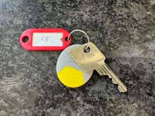
Type of keys | 1 x Bramah 85D6586
Location of keys | Handed to tenant
Number / Location of fobs | 1 fob C1D15919

Meter Readings
Type | Reading | Serial Numbers/Notes |  | Meter Location |  | Meter key used to access cupboard (if applicable)
Gas | 0179 | 68285 |  | Kitchen unit under sink |  | N/A
Electric | 04545 | L86A31701 |  | Leisure centre ground floor cupboard |  | FB2 key required
Water | N/A
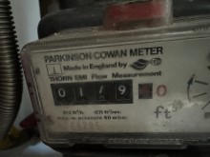 |  |  | 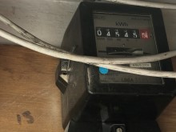

Alarms and or Detectors
Type | Quantity |  | Location | POWER Tested |  | Smoke alarm- present on all floors / C0 alarm present where a solid fuel burning appliance is present
Smoke/fire | 2 |  | 1 x hallway  1 x reception | Yes |  | Yes
Carbon Monoxide (CO) | 1 |  | 1 x kitchen | Yes |  | Yes
Security Alarm | None
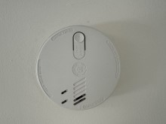 |  | 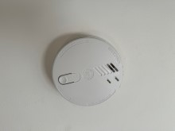 |  |  | 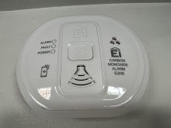

General Comments
 |  | Check-in Comments | Check-out Comments
 | Overall General Condition | Property found in good order. Usage marks to décor as noted. Chemical marks to bathroom chrome fittings, particularly bath fittings. Heavy chips within bath. 1 x dining chair heavily torn. Other dining chairs also starting to tear.
 | Overall Cleanliness | Property found cleaned to a professional level.
 | Appliances | Power tested. Clean.
 | Windows | Clean to interior.
 | Flooring | Good used order. Clean. Some chips to wood laminate as noted.
 | Curtains / Blinds | Venetian blind slats clean.
 | Lighting | All bulbs in working order unless noted.
 | Soft Furnishings | Good used order. Mattress visible side only inspected
 | Linen | Good used order.
 | Garden/Balcony | N/A.
 | Front of Property | Communal.
 | General | Tenant present for key hand over and walkthrough.

Front Door and Hallway
 | Item | Description | Check-in | Check-out
 | Doors/Windows
 | Front Door | Grey painted beaded door  1 x brushed chrome ‘15’  1 x brushed chrome knob handle/backing  1 x brushed chrome letterbox  1 x metal and brass Evva lock  1 x Yale style lock, brass surround  1 x fire closer chain | Small hole defect under number ‘5’  Black dust marks to top  Numerous small chips and shading underneath locks  Scattered small low level chips  Low level black scuffs and drip marks  Patchy  Scratched  Brass scratched
 | Door Frame | White painted  2 x exterior wall mounted doorbells | POD  Edge rubs  Not working
 | Reverse of Door | White painted plain wood door  1 x dark metal double hook  1 x chrome spyhole and cover  1 x brushed chrome letterbox  1 x brass upper lock  1 x brass twist lock / backing | Slightly patchy at low level  Paint marked  Patchy  Coating worn  Paint marked  Backing scratched
 | Door Frame | White painted | Cables tacked
 | Threshold | Part black painted wood  Part aluminium strip | Old edge chips  Patchy white marks  Light scratches
 | Windows | Frosted double glazed window  White UPVC frame  1 x brushed metal handle  White painted sill | Frosting edges chipped and worn  Tiny brown drip marks to upper glass  Heavy painted over areas throughout frame  Fittings paint marked  POD

Front Door and Hallway
 |  | Item |  | Description |  | Check-in |  | Check-out
 |  |  | Curtains / blinds |  | White wood Venetian blind  Cords and white acorns  1 x brushed metal cleat  1 x metal cup hook within red rawlplug |  | Pelmet cover slightly askew  Slats clean
 |  |  | Décor
 |  |  | Flooring |  | Light wood laminate  Light wood beading edge strips |  | Good used order  Small chip between bedroom and bathroom  Beading loose LHS bedroom
 |  |  | Skirting Boards |  | White painted |  | Cable tacked
 |  |  | Walls |  | Light grey painted |  | POD  Heat shading above radiator  1 x screw RHS window  Light scuffs under screw  High level grey spot marks RHS entry  Light mid low level shading RHS entry
 |  |  | Ceiling |  | White painted  Part light grey painted forward of reception |  | Cable tacked to edge
 |  |  | Fixtures & Fittings
 |  |  | Lighting |  | 3 x ceiling spotlights |  | Working order
 |  |  | Heating |  | Radiator behind white painted lattice front cover |  | Not tested  Tiny top edge chip  Paintwork slightly yellowed
 |  |  | Sockets and switches |  | Brushed chrome as supplied |  | Light switch patchy
 |  |  | Smoke alarm |  | Ceiling mounted smoke alarm |  | Tested, sound emitted
 |  |  | Built-in cupboard |  | White painted plain wood door  Brushed chrome lever handles / backing  Interior:  Off-white painted  White painted hat shelf  Floor continuation wood laminate |  | Décor not closely inspected due to contents restricting viewing, however appears to be low level panel cut-out to rear wall

Front Door and Hallway
 |  | Item |  | Description |  | Check-in |  | Check-out
 |  |  | Iron 1 |  | Philips iron within box |  | Not inspected
 |  |  | Iron 2 |  | White and purple Russell Hobbs iron |  | Not tested
 |  |  | Paint |  | Assorted tubs of paint |  | Seen on cupboard top shelf
 |  |  | Ironing board |  | 1 x ironing board  Black and white patterned cover |  | Cover not closely inspected
 |  |  | Mop bucket |  | Red Vileda mop bucket
 |  |  | Vacuum cleaner |  | Yellow vacuum cleaner and attachment |  | Not tested
 |  |  | Mops |  | 3 x red mop poles |  | Not inspected
 |  |  | Spare shelf |  | White long rectangular shelf |  | Stored in cupboard  Appears heavily scuffed
 |  |  | Door wedge |  | Cream rubber door wedge
 |  |  | Mirror |  | Wall mounted silver colour plastic rectangular frame mirror
 |  |  | Entry phone |  | Wall mounted white Comelit video entry phone |  | Not tested
 |  |  | Vent |  | Wall mounted brushed metal square vent |  | Appears dust shaded

Front Door and Hallway Photos
Front Door & Hallway | Front Door & Hallway door chips | Front Door & Hallway door chips
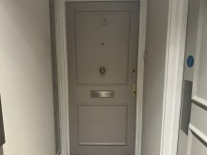 | 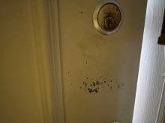 | 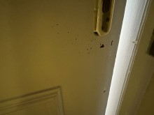
Front Door & Hallway door chips | Front Door & Hallway | Front Door & Hallway
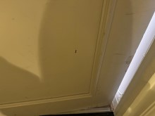 | 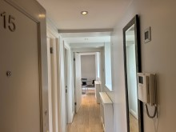 | 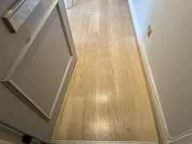
Front Door & Hallway | Front Door & Hallway | Front Door & Hallway
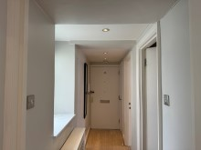 | 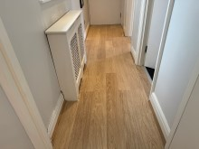 | 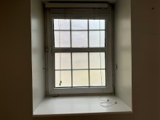
Front Door & Hallway window frosting edges worn | Front Door & Hallway window frosting edges worn | Front Door & Hallway floor chip
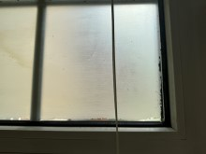 | 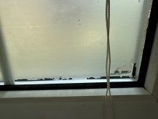 | 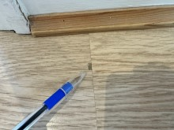
Front Door & Hallway wall heat shaded above radiator | Front Door & Hallway wall screw | Front Door & Hallway cupboard interior
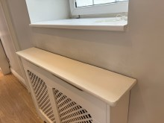 | 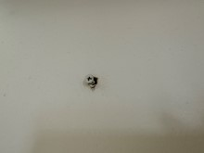 | 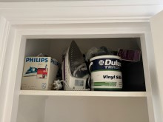
Front Door & Hallway cupboard interior | Front Door & Hallway cupboard interior | Front Door & Hallway cupboard interior
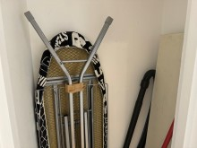 | 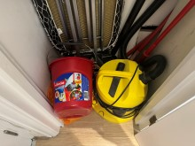 | 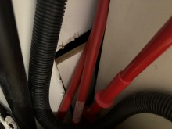

Bedroom
 | Item | Description | Check-in | Check-out
 | Doors/Windows
 | Doors | White painted plain wood door  Brushed chrome lever handle / backing | Dull  Tarnished
 | Door Frame | White painted | Few small scuffs low level RHS
 | Reverse of Door | As exterior  Brushed chrome lever handle / backing | 4 x pinholes high level  Small low level scuffs  A few red scuffs around handle
 | Door Frame | White painted | Couple of red rubs
 | Threshold | Brushed metal strip | Scuffed
 | Windows | 2 x white beaded clear double glazed windows  White UPVC frames  2 x metal lever handles  2 x small white painted locks  White painted sills | Paint marks to frames and fittings  Aged ingrained shading throughout frames  Old fitting holes high level frames  Clean to interior  Heavily soiled exterior  POD  Light scratches to RHS and small blister
 | Curtains / blinds | 2 x white wood Venetian blinds  White cords and acorns  2 x wall mounted brushed metal cleats  2 x wall mounted metal hooks within rawlplugs | Slats clean
 | Décor
 | Flooring | Continuation of wood laminate from hallway  Wood beading edge strips | Not inspected under furniture
 | Skirting Boards | White painted

Bedroom
 |  | Item |  | Description |  | Check-in |  | Check-out
 |  |  | Walls |  | Part light grey painted  Part dark grey painted LHS |  | Tiny angle edge chips LHS wardrobe  High level white flecks LHS window  Further mid level white fleck LHS window
 |  |  | Ceiling |  | White painted  Part light grey painted forward of windows |  | 1” tear forward LHS window
 |  |  | Fixtures & Fittings
 |  |  | Lighting |  | 7 x ceiling spotlights |  | Working order
 |  |  | Heating |  | Radiator behind white painted lattice front cover |  | Not tested  Tiny surface chip to top  Light cracking to front
 |  |  | Sockets and Switches |  | Brushed chrome as supplied |  | White plastic buttons to dimmer switch
 |  |  | Fittings
 |  |  | Inbuilt wardrobe |  | 2 x wood sliding doors  2 x inset metal handles  Interior LHS:  White painted  Floor continuation  Cream painted threshold  White hat shelf  Chrome hanging rail  RHS:  White painted décor  Floor continuation  Cream painted threshold  5 x white painted shelves |  | Right door slightly stiff  6” edge splinter to low level  Tiny angle chips  General usage scuffs  Paint heavily worn  Scuffed  Paint marked  Shading
 |  |  | Bookcase |  | Freestanding white laminate bookcase  5 x white shelves

Bedroom
 |  | Item |  | Description |  | Check-in | Check-out
 |  |  | Wardrobe 2 |  | Freestanding white laminate wardrobe  2 x doors  2 x brushed chrome handles  Interior:  Grey hanging rail  White laminate shelf  Further grey hanging rail  1 x chrome rail | Slightly wobbly  Interior back panel split to centre, loose at base  Old fitting holes each side under top rail  Bowed  Cracked LHS edge  Not fitted, seen on floor  Not fitted, seen on floor
 |  |  | Duvet |  | Thin white duvet | Appears to be a single duvet  Seen inside wardrobe  Not fully inspected
 |  |  | Planters |  | 2 x grey metal window boxes  6 x faux green topiary balls | 1 x sticker residue mark
 |  |  | Pictures |  | 2 x wall mounted beige, cream gilt canvas prints
 |  |  | Bed |  | Dark brown wood headboard  Inset frosted and mirror panel  Matching dark brown wood double bed base
 |  |  | Mattress |  | Pale cream self patterned double mattress | Visible side inspected  No stains
 |  |  | Mattress topper |  | Orange foam topper | Some edge chip / defects to edges
 |  |  | Mattress cover |  | White quilted double mattress cover | Appears washed  Shaded
 |  |  | Throw |  | Black and purple satin throw | A few white rub marks
 |  |  | Pillows |  | 2 x white assorted pillows | Good order  No stains
 |  |  | Scattered cushions |  | 2 x large brown, cream, blue floral stripe square cushions  1 x purple satin square cushion | Pale grey stains
 |  |  | Doorstop |  | Skirting metal white tip doorstop

Bedroom Photos
Bedroom | Bedroom | Bedroom
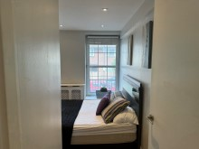 | 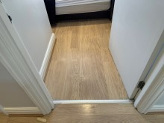 | 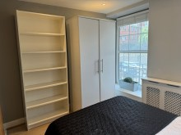
Bedroom | Bedroom door fitting holes to interior | Bedroom window frame fitting holes high level
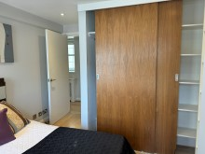 | 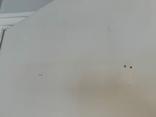 | 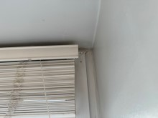
Bedroom window frame fitting holes high level | Bedroom wall white chips | Bedroom wall white chips
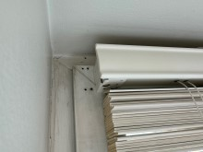 | 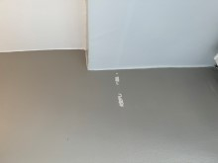 | 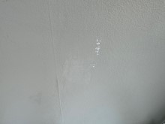
Bedroom ceiling paint flake by window | Bedroom wall angle chips | Bedroom wardrobe interior
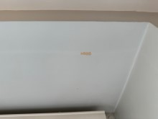 | 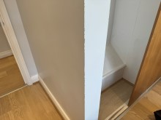 | 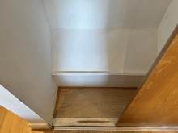
Bedroom wardrobe interior | Bedroom wardrobe door edge splinter | Bedroom wardrobe interior
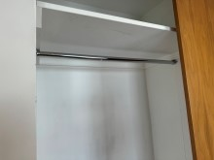 | 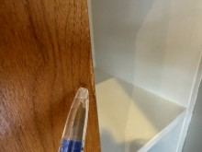 | 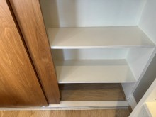
Bedroom wardrobe interior | Bedroom wardrobe interior | Bedroom wardrobe interior
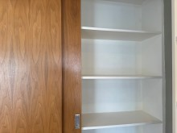 | 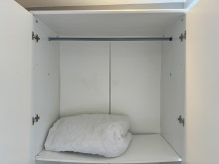 | 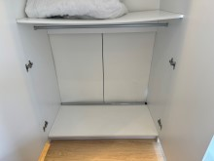
Bedroom wardrobe interior shelf cracked | Bedroom | Bedroom
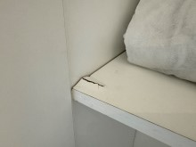 | 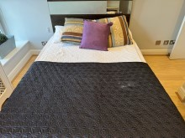 | 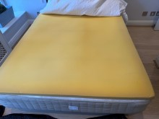
Bedroom | Bedroom foam topper example of edge defect | Bedroom cushion stained
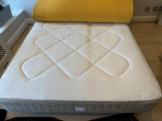 | 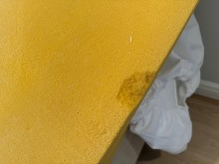 | 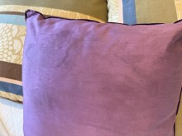

Bathroom
 | Item | Description | Check-in | Check-out
 | Doors/Windows
 | Doors | White painted plain wood door  Brushed chrome lever handle / backing | Low level line mark painted over  Further line marks to leading edge painted over
 | Door Frame | White painted | POD  Black dust marks by hinges
 | Reverse of Door | As exterior  Brushed chrome lever handle / backing  2 x chrome single hooks  Brass hook and keep | Painted over line marks to low level and leading edge  Paintwork appears yellowed  Dull  Tarnished  1 x screw missing to each  Tarnished
 | Door Frame | White painted | Edge rubs
 | Threshold | Metal strip | Light scratches
 | Windows | N/A
 | Curtains / blinds | N/A
 | Décor
 | Flooring | Black square ceramic tiles  Black grout | Appear to be 2 x different varieties of black tiles  White marks to grout under basin
 | Skirting Boards | N/A
 | Walls | Part light grey painted  Part beige rectangular tiles  Cream grout | POD  4 x screw heads to access panel behind WC  Scuff under flush  1 x white plastic stick-on hook  Cracking LHS basin  Grout slightly shaded in places  Corner sealant thickly applied

Bathroom
 |  | Item |  | Description |  | Check-in | Check-out
 |  |  | Ceiling |  | White painted | Appears quite heavily shaded  Old water stain to edge above WC  Starting to flake RHS showerhead
 |  |  | Fixtures & Fittings
 |  |  | Lighting |  | 3 x ceiling spotlights  3 x spotlights with grey plastic canopy above basin | Working order  Not working
 |  |  | Heating |  | Chrome ladder style radiator  White caps intact | Not tested  Heavy rusting
 |  |  | Sockets and switches |  | N/A
 |  |  | WC roll holder |  | Wall mounted brushed chrome holder with ledge above | Light cleaning scratches
 |  |  | WC |  | White WC  White soft close seat and lid  Chrome push flush | Hairline crack to rear  Sealant thickly applied
 |  |  | WC brush |  | White plastic WC brush and holder | Used order
 |  |  | Bin |  | Small chrome pedal bin and lid | Few tiny dents
 |  |  | Mirror |  | Wall mounted mirror
 |  |  | Basin |  | Wall mounted white basin  Chrome mixer tap  Chrome push release plug | Generally aged cream in colour  Thick sealant to rear  Tarnished  Smeared  Dull  Tiny rust scratches
 |  |  | Vanity unit |  | 2 x black gloss vanity drawers | General heavy aged edge wear  Corner chips  Bottom drawer top surface cracked

Bathroom
 |  | Item |  | Description | Check-in | Check-out
 |  |  | Bath | White bath  Chrome pop-up plug and control  Wall mounted chrome spout, shower lever and showerhead and hose  Further wall mounted chrome double control / backing  Wall mounted chrome square showerhead  White framed clear glass folding shower screen  White laminate bath panel with chrome screw covers | Very thick white sealant which is starting to perish under controls  Numerous chips throughout bath surface  Heavily aged copper in colour  Heavy chemical tarnishing  2 x screw cap covers not seen  Dull tarnish smears  Edge sealant blackened  Heavy chemical tarnishing  Some spray jet inserts not seen  Old scale to base of frame
 |  |  | Extractor fan | Ceiling mounted white extractor fan | Working order

Bathroom Photos
Bathroom | Bathroom | Bathroom
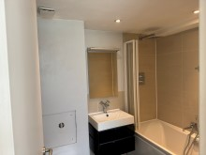 | 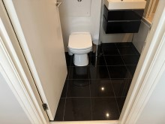 | 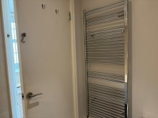
Bathroom door defects | Bathroom | Bathroom wall access panel
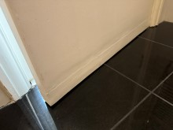 | 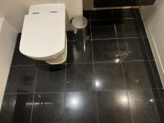 | 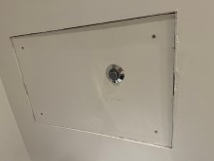
Bathroom stick-on hook | Bathroom | Bathroom ceiling starting to flake above bath
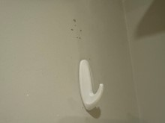 | 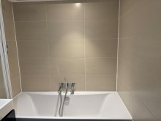 | 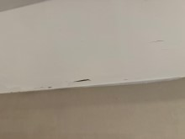
Bathroom ceiling old water stain by extractor fan | Bathroom | Bathroom radiator rusty
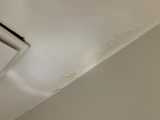 | 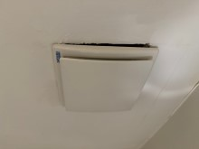 | 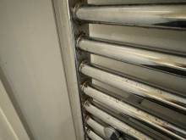
Bathroom radiator rusty | Bathroom | Bathroom WC crack
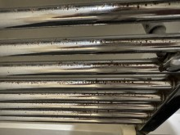 | 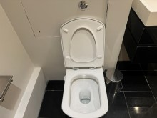 | 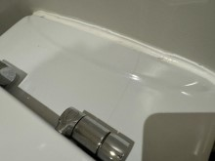
Bathroom lights not working | Bathroom | Bathroom basin tap tarnished
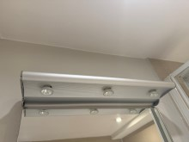 | 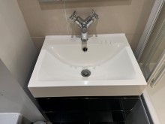 | 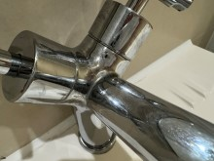
Bathroom basin plug heavily worn & scratched | Bathroom vanity drawer edge wear & corner chipped | Bathroom vanity drawer edge wear and corner chipped
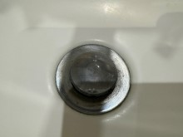 | 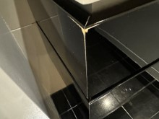 | 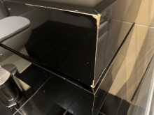
Bathroom vanity drawer top edge crack | Bathroom | Bathroom bath base numerous chips
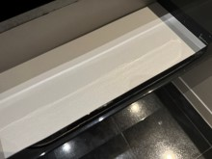 | 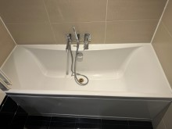 | 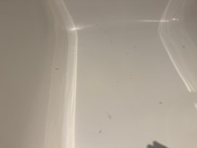
Bathroom bath base numerous chips | Bathroom bath plug heavily worn | Bathroom bath control & backing tarnished
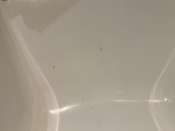 | 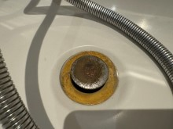 | 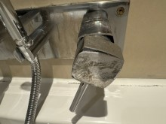
Bathroom bath backing tarnished | Bathroom | Bathroom shower control seal black marks
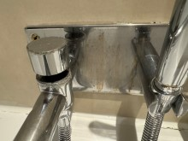 | 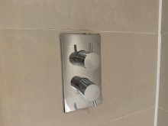 | 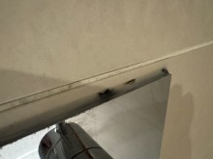
Bathroom shower head tarnished | Bathroom shower head jet inserts not seen | Bathroom shower screen frame scaled
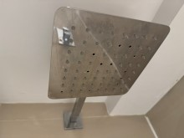 | 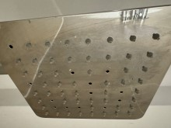 | 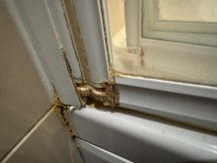

Reception
 | Item | Description | Check-in | Check-out
 | Doors/Windows
 | Doors | White painted plain wood door  Brushed chrome lever handle / backing | Hinges blackened  Tarnish smears
 | Door Frame | White painted | Cable through high level  Light shading
 | Reverse of Door | As exterior  Brushed chrome lever handle / backing | Collar slightly loose
 | Door Frame | White painted | Cable through high and low level
 | Threshold | N/A
 | Windows | 3 x white beaded clear double glazed windows  White UPVC frames  3 x brushed metal handles  3 x small white locks  White painted sills | Wall paint overspill throughout frames  Aged ingrained shading throughout frames  Old fitting holes high level  All fittings paint marked  Clean to interior  POD  Front RHS heavily cracked to rear
 | Curtains / blinds | 3 x white wood Venetian blinds  White cords and acorns  3 x wall mounted brushed metal cleats  3 x wall mounted small metal hooks in rawlplugs | 1 x pelmet cover askew  Slats clean
 | Décor
 | Flooring | Continuation of wood laminate from hallway  Wood beading edge strips | Cable tacked to beading RHS  Small surface chip forward of entry  Light lifting to laminate board edges when viewed in certain light, particularly leading into kitchen  Several small chips LHS kitchen  1” L-crack and 1” surface chip forward of kitchen  Not inspected under furniture
 | Skirting Boards | White painted

Reception
 |  | Item |  | Description |  | Check-in | Check-out
 |  |  | Walls |  | Part light grey painted  Part darker grey painted opposite entry and behind shelves | Heavy heat shading above radiator  POD  Patchy white rub marks and small grey plasterboard type studs around built-in shelf area
 |  |  | Ceiling |  | White painted | Light shading
 |  |  | Fixtures & Fittings
 |  |  | Lighting |  | 10 x ceiling spotlights | Working order  1 x surround not quite flush
 |  |  | Heating |  | Radiator behind white painted lattice front cover | Not tested  Small front top edge chip  LHS angle scuffs
 |  |  | Sockets and Switches |  | White plastic and brushed chrome as supplied
 |  |  | Fittings
 |  |  | Smoke alarm |  | Ceiling mounted smoke alarm | Tested, sound emitted
 |  |  | Doorstop |  | Floor mounted black rubber and chrome doorstop
 |  |  | Thermostat |  | Wall mounted Worcester thermostat / boiler control | Dial cover appears to be missing?
 |  |  | TV unit |  | Low level dark brown wood unit  4 x doors  4 x small chrome handles  Brushed metal legs  Interior:  Dark brown wood shelf to each side | Good, although used order  Dark chemical type stain to top LHS area  Several scratches to top  Ring mark to top front RHS corner
 |  |  | Picture frames |  | 2 x silver coloured rectangular picture frames | Pictures not provided

Reception
 |  | Item |  | Description | Check-in | Check-out
 |  |  | Vases | 1 x brushed metal vase with faux green leaf plant and thistles  3 x assorted clear glass bottle neck vases with faux green leaf, white, purple flowers  1 x small brushed metal vase / candle holder  1 white ceramic square vase / candle holder  1 x purple glass vase with faux green leaf, yellow flowers | Good used order
 |  |  | Bin | Black plastic kitchen bin and swing lid | Used order
 |  |  | Sofa | Large grey 3-seater sofa  2 x back cushions  Polished chrome legs | Good, although used order  General aged shading and light wear to seat, particularly centre front area  Small grey mark to seat  Brown ring mark to seat  Yellow water type staining to top of 1 x arm  Rust spotting to legs
 |  |  | Scatter cushions | 2 x sage green floral large square  2 x grey square matching the sofa  2 x further plain grey square  1 x grey, black stripe rectangular | Good used order
 |  |  | Coffee tables | Medium and small white, black moulded plastic tables | Good, although used order  General surface scratches  1 x tiny black chip to smaller table
 |  |  | Shelves | 2 x built-in white painted shelves  White painted ledge under
 |  |  | Pictures | 2 x wall mounted white, black splash pattern canvases
 |  |  | Dining table | Clear glass round top table  Brushed chrome pedestal base | Good, although used order  Scattered light scratches throughout glass  Cleaning scratch marks to base

Reception
 |  | Item |  | Description | Check-in | Check-out
 |  |  | Dining chairs | 4 x dark brown leather effect seat and back dining chairs  Chrome legs | 1 x heavily torn to seat and back  Stitching coming undone  Other 3 x in good, although used order  1 x further seat edge starting to tear  Back metal starting to pop through top corners of leather  1 x further back top corner stitching splitting  2 x further seat edges starting to fray

Reception Photos
Reception | Reception | Reception
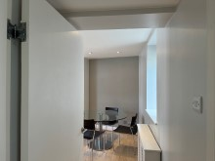 | 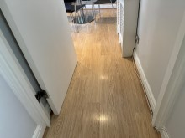 | 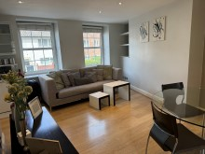
Reception | Reception window frame fitting holes high level | Reception window frame paint marks
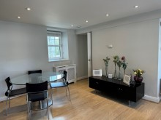 | 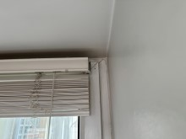 | 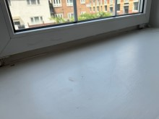
Reception window sill cracks | Reception blind pelmet askew | Reception floor chip
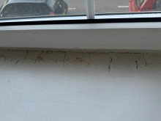 | 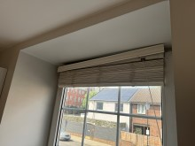 | 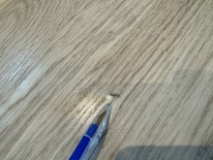
Reception floor chip | Reception floor chips | Reception floor dent
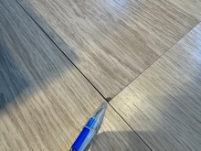 | 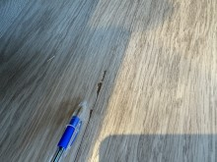 | 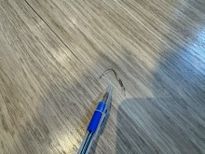
Reception floor chip | Reception wall heat shaded above radiator | Reception
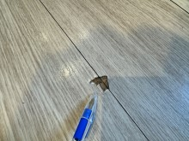 | 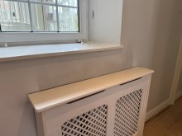 | 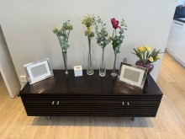
Reception cabinet top marked | Reception cabinet top scratched | Reception cabinet top scratched
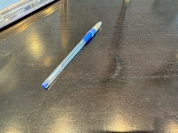 | 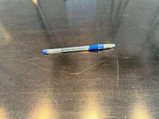 | 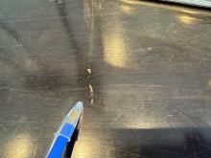
Reception cabinet top ring mark | Reception sofa & tables | Reception sofa seat discoloured
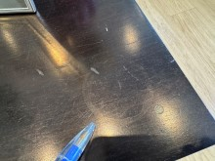 | 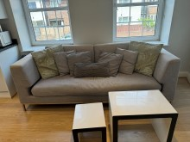 | 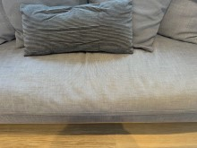
Reception sofa stain | Reception sofa stain | Reception sofa arm stain
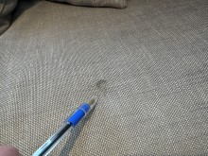 | 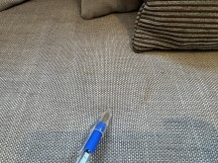 | 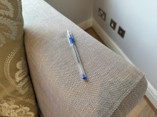
Reception table chip | Reception | Reception dining chair torn
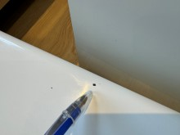 | 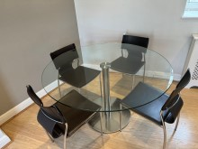 | 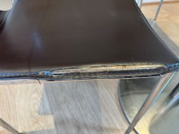
Reception dining chair torn | Reception dining chair torn | Reception dining chair torn
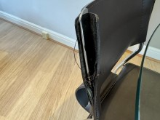 | 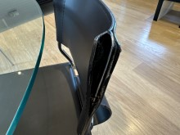 | 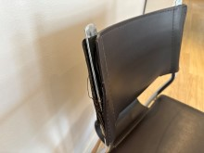
Reception dining chair seat edge fraying | Reception dining chair torn | Reception dining chair seat edge fray
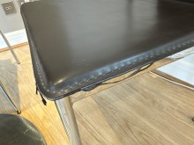 | 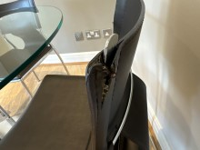 | 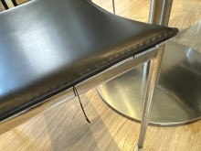

Open Plan Kitchen
 | Item | Description | Check-in | Check-out
 | Doors/Windows
 | Doors | N/A
 | Door Frame | N/A
 | Reverse of Door | N/A
 | Door Frame | N/A
 | Threshold | N/A
 | Windows | White beaded clear double glazed window  White UPVC frame  1 x metal lever handle  1 x small white lock  Clear glass sill / ledge | Heavy aged ingrained shading throughout frame  Paint marks  Clean to interior  Appears to have patchy shading marks under glass and light cracking under glass
 | Curtains / blinds | White wood Venetian blind with white cords and acorns  1 x wall mounted brushed metal cleat  1 x wall mounted metal hook in rawlplug | Pelmet askew  Appears to have ingrained dust to pelmet  Slats clean
 | Décor
 | Flooring | Continuation of wood laminate from reception area  Wood beading edge strips | Slight gap in between boards  2 x small surface chips  Few tiny surface chips forward of dishwasher and oven
 | Skirting Boards | White painted | POD
 | Walls | Light grey painted | Angle shading LHS entry  General patchy shading throughout  Patchy washed appearance throughout  Painted over grease splashing LHS hob  Heat shading RHS boiler cupboard  Low level paint flakes LHS window recess
 | Ceiling | White painted  Part light grey painted beam | Patchy shading

Open Plan Kitchen
 |  | Item |  | Description |  | Check-in |  | Check-out
 |  |  | Fixtures & Fittings
 |  |  | Lighting |  | 3 x ceiling spotlights |  | Working order
 |  |  | Heating |  | White painted single metal radiator  Caps intact |  | Not tested  Heavily chipped to top  Aged staining to caps  Small bottom edge chips
 |  |  | Sockets and switches |  | Brushed chrome as supplied |  | Patchy  Hob fused switch backing loose / not flush
 |  |  | Carbon monoxide alarm |  | Wall mounted Ei carbon monoxide alarm |  | Tested, sound emitted
 |  |  | Units |  | White laminate wall and base unit doors and drawers  Brushed metal handles  White laminate kickboards  Interior:  White laminate shelves  2 x glass fronted wall unit doors |  | Dummy panel laminate warping underneath boiler cupboard door  Fixed panel above boiler covered with glue marks to edge, cracked to wall side  Boiler cupboard not closing flush  Kickboard slightly loose  Bottom edge slightly wrapped under sink  Base side support bottom edge chipped to RHS of dishwasher and laminate appears to be slightly lifting either side fridge freezer  Appears to have patchy marks in between glass and low level panels
 |  |  | Worktop |  | Black granite worktop and matching upstands |  | Few tiny top edge chips above dishwasher
 |  |  | Splashback |  | Wall mounted brushed stainless steel hob splashback |  | Patchy rectangular residue mark LHS  Some residual grey spot marks
 |  |  | Sink |  | Stainless steel bowl sink with integral drainer  Chrome mixer tap  Perforated plug |  | Normal usage scratch marks  Few tiny dents in bowl  Nib discoloured

Open Plan Kitchen
 |  | Item |  | Description |  | Check-in | Check-out
 |  |  | Fuse box |  | Interior wall unit fuse box LHS cooker hood with flap
 |  |  | Boiler |  | Built-in Worcester boiler within wall unit  Instruction manual seen | Control flap cover detached, seen to base  Very dusty to interior base  Unit door bottom hinge detached  Fitting marks under hinge
 |  |  | Appliances
 |  |  | Cooker hood |  | Brushed stainless steel Neff cooker hood  2 x lights and covers | Power tested  Dull smear marks throughout canopy
 |  |  | Hob |  | Brushed stainless steel Neff 4-ring gas hob  2 x black pan stands | Power tested
 |  |  | Oven |  | Brushed stainless steel Whirlpool oven  1 x chrome shelf  2 x grey enamel grill pans  2 x assorted black baking trays  Interior light | Power tested  Working order
 |  |  | Washing machine |  | Built-in white Indesit IWDE126 washer dryer | Power tested  Unable to open soap tray fully / stuck  Light aged shading within door rubber
 |  |  | Dishwasher |  | Brushed stainless steel Siemens dishwasher  2 x drawers  1 x cutlery basket | Power tested  Door catches against washing machine unit door on opening  General patchy smears throughout stainless steel
 |  |  | Fridge freezer |  | Built-in Baumatic fridge freezer  1 x freezer flap  Light and cover  1 x half glass shelf, white trim  1 x full glass shelf, white trim  1 x white plastic crisper box and lid  2 x plastic door shelves, 1 x flap  1 x egg tray | Power tested  Working order  Bottom shelf cracked to base

Open Plan Kitchen
 |  | Item |  | Description | Check-in | Check-out
 |  |  | Microwave | Grey Cookworks microwave  Interior light  1 x glass plate | Power tested  Light brown spotting to interior roof front edge  A few tiny chips to exterior door top edge  Working order
 |  |  | Furnishings
 |  |  | Glassware | 2 x champagne glasses  2 x assorted wine glasses
 |  |  | Knives | 1 x wood block  4 x assorted black handled knives | Used order
 |  |  | Utensils | 1 x metal stand  1 x metal cream handled pizza slice  1 x metal cream handled grater  1 x metal cream handled vegetable peeler  1 x metal cream handled can opener | Used order
 |  |  | Cutlery | 1 x metal mesh tray  Assorted stainless steel and black handled cutlery
 |  |  | Further utensils | 1 x chrome corkscrew  1 x orange handled vegetable peeler
 |  |  | Baking tray | Rectangular metal baking tray  Assorted instruction manuals seen within  1 x Byron doorbell receiver within | Tray in use, aged order  Not tested
 |  |  | Further utensils | Stainless steel and black tong  1 x black handled cook spoon  1 x black handled ladle | Used order
 |  |  | Saucepan | 1 x black handled saucepan  1 x glass lid | Used order  Scratched
 |  |  | Chopping board | 1 x glass chopping board
 |  |  | Spare fridge shelf | 1 x plastic half width door shelf | Not fitted
 |  |  | Bun tray | 1 x Circulon bun tray

Open Plan Kitchen
 |  | Item |  | Description | Check-in | Check-out
 |  |  | Further saucepans | 3 x assorted black chrome handled saucepans  1 x black metal handled wok | Used order  Scratched  Worn
 |  |  | Plastic bowl | 1 x white, black rectangular bowl / sieve | Stored under sink  Not closely inspected
 |  |  | Gas meter | Fitted meter under sink
 |  |  | Plate drainer | 1 x metal 2-tier plate drainer / sink tidy | Used order  Rust spots to base
 |  |  | Kettle | 1 x black Bosch jug kettle | Not tested  White scale to spout
 |  |  | Toaster | 1 x grey and chrome Russell Hobbs 2-slot toaster | Not tested  Ionised marks  Sticker residue
 |  |  | Storage pots | 3 x brushed stainless steel tea, coffee, sugar pots and lids | Used order  Worn patchy marks
 |  |  | Mugs | 8 x assorted mugs
 |  |  | Plates | 4 x white square  4 x brown square  4 x cream square  2 x cream square bowls  4 x white square bowls  1 x white small round plate  1 x white round bowl | Used order  Couple edge chips
 |  |  | Further glasses | 1 x wine  2 x assorted tall tumblers

Open Plan Kitchen Photos
Kitchen | Kitchen window frame paint marks | Kitchen window sill
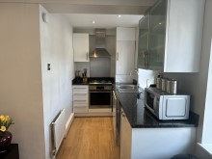 | 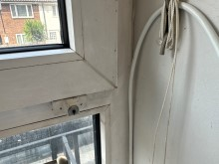 | 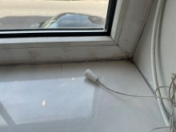
Kitchen flooring | Kitchen floor chip | Kitchen floor chip
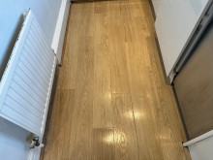 | 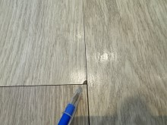 | 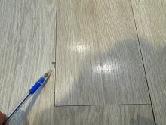
Kitchen floor chips | Kitchen floor chips | Kitchen floor chips
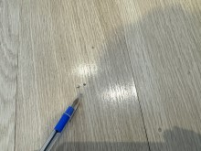 | 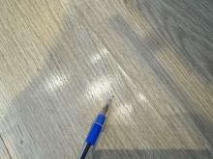 | 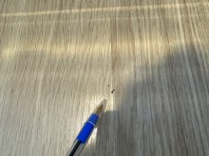
Kitchen wall patchy | Kitchen wall shaded by boiler cupboard | Kitchen wall in window recess
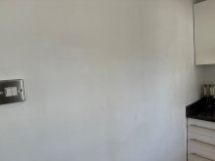 | 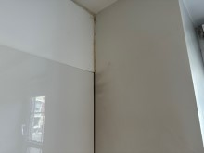 | 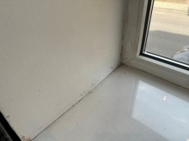
Kitchen socket loose | Kitchen unit panel warped under boiler cupboard | Kitchen unit panel glue marks above boiler cupboard
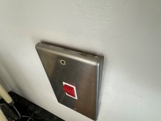 | 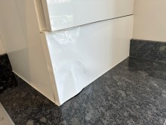 | 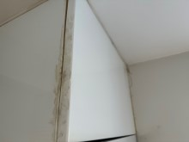
Kitchen boiler cupboard door hinge detached | Kitchen unit base panel chip | Kitchen worktop edge chip
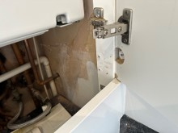 | 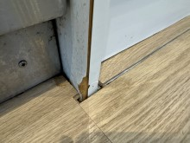 | 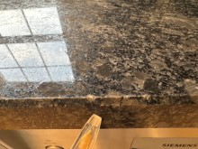
Kitchen worktop edge chip | Kitchen worktop edge chip | Kitchen
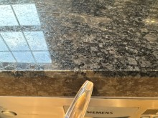 | 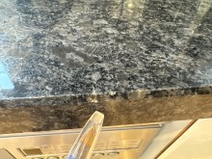 | 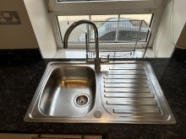
Kitchen sink plug nib worn | Kitchen | Kitchen
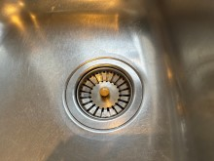 | 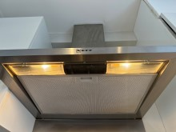 | 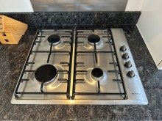
Kitchen | Kitchen | Kitchen
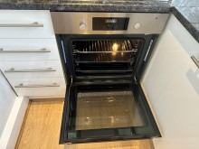 | 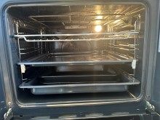 | 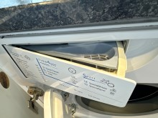
Kitchen | Kitchen | Kitchen
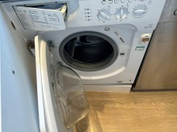 | 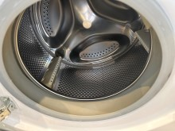 | 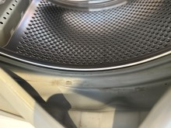
Kitchen | Kitchen | Kitchen
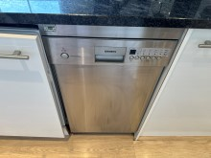 | 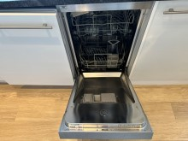 | 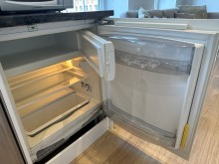
Kitchen fridge door shelf crack | Kitchen | Kitchen
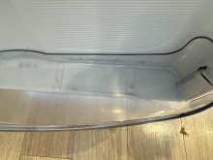 | 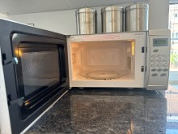 | 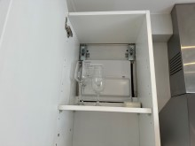
Kitchen | Kitchen | Kitchen
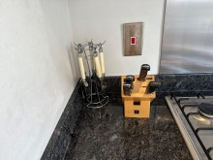 | 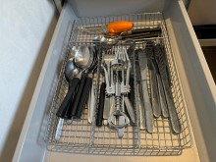 | 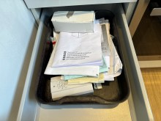
Kitchen | Kitchen | Kitchen
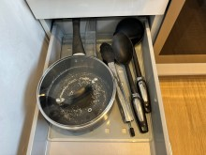 | 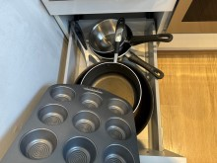 | 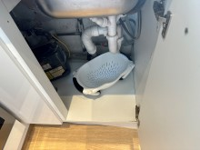
Kitchen | Kitchen | Kitchen
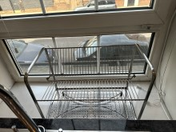 | 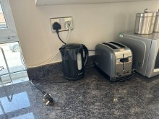 | 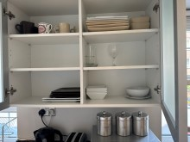

Disclaimer
Important Information to be read by all involved parties
This inventory provides a fair and accurate record of the contents and condition of the property as well as the property’s internal condition. The sole responsibility lies with the tenant, landlord or any agent working on the landlord’s behalf to fully agree with this report and sign it to confirm this. This inventory is for making comparisons at the end of the tenancy agreement that it relates to. This inventory is prepared “as seen snapshot” of the property and its contents at the time of the inspection and is compiled as a fair and accurate record of the property’s internal condition and its contents and should not be used as an accurate description of each and every piece of furniture and equipment, or as a structural survey report. We do not comment on any structural defects. Therefore as the Inventory Clerk preparing this inventory is not an expert on fabrics, woods, materials, antiques, etc., nor is a qualified surveyor or valuer, they are not required to state whether an item is antique, made of precious metals, of unique origin, or whether it is new despite the appearance being obviously so. No attempt has been made to value the property or any of its contents. We will fully check blinds and curtains to ensure they are secure and fully functioning. We will also record if tie backs are present for long chords & we will accept no liability for any blinds or curtains that are found to have issues after our inspection. We must be told if any items within the property are brand new so that this can be stated at the time the report is carried out. Please be advised that the items left in lofts, cellars or in locked rooms or cupboards, garages and sheds that have not been noted in the inventory are the sole responsibility of the landlord. We will need instruction to check areas such as lofts, cellars, basements, front and back gardens, garages and sheds. The moving of any heavy furniture items or appliances will not be undertaken and therefore some observations may be restricted where such items restrict full view. We will not lift any mattresses or be able to view in any way the undersides of such; this could miss any damage present. Our clerks will attempt to note all or any present odours; there sense of smells will alter and so the accuracy of this is not something we can be held accountable for. Where inventories are completed with tenants in situ and it is deemed difficult for clerks to differentiate between that belonging to the landlord or tenant, then the report may contain inaccuracies for which the clerk cannot be held responsible. Any images/photographs taken may not reflect accurately the condition or damage as stated in our report as lighting and any other such conditions can greatly affect these images. Please use these images in connection with the written report. It is strongly advised that the receipt. This report should be thoroughly checked. Please note clerk cannot be held responsible for any errors, omissions or issues you may feel are contained within our reports. It is very important that any notes required within the report are mentioned to the clerk at the time of the report being complied. We cannot be held responsible for any issues or omissions.
When a check out report is made all comparisons will be made at the time between how the property has been left with the original inventory report taken at the start of the tenancy. Meters will be checked where seen and where access is made possible. We will attempt to note the location of any visible stop cocks/safety values. We cannot be held responsible for any discrepancies or issues with our readings. The utility companies must be asked to check any meter readings given or required. At the check-out all items and goods not belonging to the property/tenancy must have been removed and cleaning must have been fully completed. The property must be left in the condition it was found on the day the tenancy started.
Safety Disclaimer
The Inventory relates only to the furniture, furnishings and all landlord’s equipment and contents in the property. It is no guarantee of, or safety of, any such equipment or contents, merely a record that such items exist in the property at the date of the inventory and the superficial condition of the items. None of the electrical boilers, gas fires, hobs, water supplies, fire alarms, radiators or gas appliances have been checked for working order; this is not part of our standard report. Should any of the electrical appliances, switches and sockets or anything else mentioned be tested for power or working order it is absolutely no indication of its safety in any way. We are just stating the item or fixture is present, and its condition, at the time of this report. Blinds and cord safety 1st October 2014; all binds etc. must have safe pull controls/cords. We will not be held liable for any cords/controls that do not comply, whether we have noted this or not. Overlong cords can cause a health and safety issue. We do not in any circumstance look for signs of Legionella and will not in any way be held liable for such within any premises we carry out any such report on.
Furniture & Furnishings (Fire) (Safety) Regulations 1988 as amended 1993
Relevant furniture and furnishings, which have the appropriate label complying with the above regulations, can be indicated on the inventory as “fire resistant”, but is not considered a part of our services. Where we see an F&F label this does not mean that we are stating in any way that this item is suitable and complies.
PLEASE NOTE:
All furniture needs to be returned to it is original position as noted on Check-in inventory report, failure to do so may result in the item being listed as not seen and result in the tenant being charged for the missing item.
Fireguards
Where there are loose fireguards, not part of a heater, gas or electric fire this may be indicated on the inventory.
Smoke Alarm/Detectors& Carbon Monoxide Alarm/Detectors
It is the tenant’s responsibility, or any other party such as the landlords or their agent, to inspect any smoke /alarm detector fitted in the property at regular intervals to ensure they are in full working order as per the manufacturer’s instructions. We are not responsible to check these or if we have checked the power or working order of such equipment, this does not mean in any way it is still functioning or working effectively after our checks.
The Smoke and Carbon Monoxide Alarm England regulations 2015
Smoke alarms/detectors and carbon monoxide alarms/detectors are tested for power only in compliance with The Smoke and Carbon Monoxide Alarm England Regulations 2015.

This law is under The Smoke and Carbon Monoxide Alarm England regulations 2015. Under this law you must provide a working and tested smoke alarm/detector on every floor of the property and a carbon monoxide alarm/detector in every room that contains a solid fuel combustion appliance. Power and/or functionality tests must also be carried out on every new tenancy by law, via the Tenant / Instructing Principle / Landlord. As stated, we accept no responsibility whatsoever for any testing of, recording of missing or present and/or working order of any such smoke alarm/detectors and or carbon monoxide detectors within a property following a report or visit from our clerks. Where smoke alarms and CO Detectors are tested this is for power only and should not be taken to mean that the alarms are in full working order. No responsibility is taken for any damage or malfunction occurring during the testing of such alarms.

END OF TENANCY INFORMATION
***IMPORTANT - TO BE READ***
Please read all these notes fully as they state what needs to happen for a smooth check out process as well as what our clerks are trained to look for and note within a property.
FULL CLEAN: This must be very thorough. Floors, walls, sanitary ware, windows, woodwork, all kitchen units, all rooms, ovens, cooker hoods, fridges and freezers, extractor fans, wardrobes, any linens and beddings. We will be inspecting all furnishings and appliances. You are required to return the property the same way as noted in the original inventory report; most managing agents and landlords will have to instruct professional cleaners if this is not done, this cost will be from your deposit.
FLOORING: Needs to be fully cleaned. If there are any stains or marks, the flooring should be professionally cleaned by a regulated cleaning company. You can be charged for stains or marks of any kind. If a flooring is badly damaged you may be charged for its entire replacement.
UTENSILS: This will all be inspected for damage and soiling. It should all be thoroughly cleaned and in the same place as at the beginning of the tenancy or it could be noted as missing.
BEDROOM FURNISHINGS: All beds and their respective mattresses and bases will be thoroughly examined for stains and damage. Charges would be made if there are any issues not noted on your original report. If any sheets, duvets etc. were provided these will need to be cleaned and pressed. All linen should be placed on top of the respective bed so that the bed can be fully inspected.
ALL FURNISHINGS: These should be in a similar condition as provided and will be fully inspected. You should take all means necessary to protect all furnishings during your tenancy, as damage can result in deductions from your deposit. This includes all marks, stains, scratches, loose joins, polish finishes, burns, ring marks, soiling or discolouration etc. All furnishings and any equipment must be returned to its original position or it may not be noted as present in the check out and may incur a charge for the missing item.
GENERAL DECORATION: Any excessive damage, marking, scratches etc. can be deemed as beyond fair wear & tear. This can include nails, screws and hooks in walls, furniture marks etc. Please always gain written permission from all relevant parties prior to making alterations or changes of any kind.
DRAINS: These should be tested and running free with no blockages.
LIGHTBULBS: These should all be replaced and fully working.
KEYS: All keys from the beginning of the tenancy must be available, ready and clearly marked, including any cut during the tenancy. Lost keys can result in a charge for the replacement of the property’s locks.
GARDENS: The front and back gardens will need to be maintained throughout your tenancy. Lawn cutting, weeding, maintaining flower beds and any other seasonal works required. We would suggest you liaise with your landlord and or managing agent regarding this and any specific needs.
RUBBISH: Any and all rubbish or excess rubbish should be completely removed from inside and outside the property, as organising this will incur a cost for removal.
ODOURS: Any odours present in the property must be eradicated prior to the check out. These often include cooking smells, food smells, the smell of smoking, sewage smells, damp smells or the smell of any pets.

All of the above useful information will vary and depend upon discrepancies, including how the property was at the beginning of any tenancy and what was agreed.

Signatures
By signing below you confirm that you have received the keys to the property. You will have 7 days upon receipt to register any queries with our office, otherwise it is understood you are in agreement with the content of the report regardless of the presence of signatures. If the property is rented to multiple tenants, one tenant signature or one tenant receiving the report denotes approval of all tenants. We the tenants are satisfied of the presence and power testing of both smoke alarms/detectors on all floors within the property and carbon monoxide alarms/detectors where a solid fuel burning combustion appliance is present.
Tenant
Name: Date:

Signature:

Landlord/Verifier
Name: Date:

Signature:

