CHECK-OUT REPORT

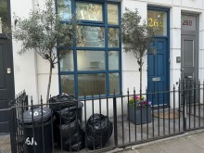
SAMPLE
Instructing Party: SAMPLE |  | Conducted by: Perfect Inventories
Perfect Inventories
perfectinventories@gmail.com
Tel: 07464709201
Date | Time | Bedrooms | Extra Areas
SAMPLE | 1.30pm | 2 | Front Exterior, Terrace, Stairs & Lower Hall, En-Suite Shower Room, Patio


Whilst every care is taken to ensure the accuracy of this inventory, it is strongly advised that the accuracy of this report lies with the Landlord, Tenant and/or any other involved party or instructing principle and that any queries or discrepancies relating to the description or content be addressed to Perfect Inventories – perfectinven@gmail.comwithin 7 days of an receipt. This report should be thoroughly checked. If we do not hear from you within this period in writing, we can assume that this report is an accurate representation of the condition of the property. Please note clerk cannot be held responsible for any errors, omissions, differences in opinions or issues you may feel are contained within our reports.
This Inventory has been prepared on the accepted principle that in the absence of comments an item is free from obvious damage or soiling.

Tenants are strongly advised to read the End of Tenancy advisory Information to ensure that unnecessary charges are not applied at the end of tenancy.

Contents
Overview 3
General Comments 6
Front Door and Hallway 8
Front Door and Hallway Photos 11
Reception 18
Reception Photos 22
Kitchen 30
Kitchen Photos 35
Terrace 43
Terrace Photos 44
Stairs & Lower Hall 46
Stairs & Lower Hall Photos 48
Bedroom 1 51
Bedroom 1 Photos 56
En-suite Shower Room 64
En-Suite Shower Room Photos 67
Bathroom 70
Bathroom Photos 73
Bedroom 2 76
Bedroom 2 Photos 79
Patio 83
Patio Photos 84
Disclaimer 85
END OF TENANCY INFORMATION 87
Signatures 88

Overview
Property Details
Is the property occupied? | No | Is the property furnished? | No
Type of property | 2 Bedroom, 2 Bathroom Split Level Flat | Supporting document | Perfect Inventories dated 28th March 2022
Key Details
Number of keys | 3 x Sets | 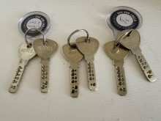
Type of keys | 3 x Banham 460091  3 x Banham 489183
Location of keys | 2 x Sets with Corridy  1 x Set left in flat  Internal keys, terrace, patio and window keys noted within report
Number / Location of fobs

Meter Readings
Type | Reading | Serial Numbers/Notes |  | Meter Location |  | Meter key used to access cupboard (if applicable)
Gas | 9899 | 414024 |  | Bedroom 1 cupboard |  | N/A
Electric | 95894 | F71A05983 |  | Bedroom 1 cupboard (on stairs) |  | N/A
Water | N/A
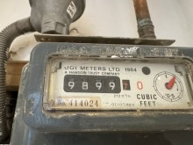 |  |  | 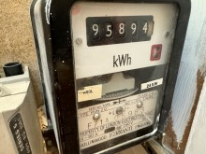

Alarms and or Detectors
Type | Quantity |  | Location | POWER Tested |  | Smoke alarm- present on all floors / C0 alarm present where a solid fuel burning appliance is present
Smoke/fire | 3 |  | 1 x Hallway  1 x Reception  1 x Lower ground hall | Yes |  | Yes
Carbon Monoxide (CO) | 1 |  | Kitchen | Yes |  | Yes
Security Alarm | None
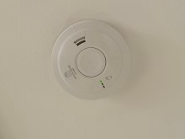 |  | 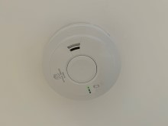 |  |  | 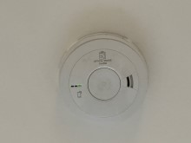
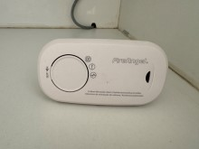

General Comments
 |  | Check-in Comments | Check-out Comments
 | Overall General Condition | Property found in very good order having been mostly refurbished and freshly painted, March 2022 | Some heavy black scuffs to skirting boards and walls in places. Screws and screw holes, child gate fitting removal holes and marks noted to walls. Dark heat candle type shading in reception by shelves. Some child gates fitted as additional items. Kitchen unit child locks fitted. 1 x door stuck under sink, unable to open. Bedroom 1 carpet heavily stained, some stains appear to be pet urine stains and yellowing within carpets also some small moth holes seen. Bedroom 2 wall low level damp by patio doors. Bathroom wall dent damaged caused by door handle. Bathroom basin tap heavily chemically damaged. Bath shower control also chemical marked
 | Overall Cleanliness | Property has been cleaned to a professional level throughout | Property has been cleaned to a professional level with some omissions as noted, see report
 | Appliances | Part as new, March 2022, part good order, all power tested, clean. Dishwasher door drops a bit quickly on opening | Power tested. Clean
 | Windows | Clean inside and out | Clean inside and out except if noted
 | Flooring | Carpet as new, March 2022, clean. Hard floors clean, marks as noted to include cracked tiles in bathroom | Carpet professionally cleaned, still damp/wet during inspection. Bedroom 1 carpet heavily stained, some stains appear to be pet urine stains and yellowing within carpets also some small moth holes seen. En-suite lino heavily yellow stained. Some ants seen crawling around on reception and kitchen floors
 | Curtains / Blinds | As new, March 2022, clean. Electric blinds in working order | Electric blinds not working during check-out, although the blue light flashes on the remote controls
 | Lighting | All bulbs in working order, unless noted | All bulbs in working order unless noted, see report
 | Soft Furnishings | N/A | N/A however additional furniture item seen to include bed within bedroom 2 and mattress stained, some bagged items in reception and miscellaneous items within kitchen
 | Linen | N/A | N/A
 | Garden/Balcony | Good order although dusty and sand covering surfaces from recent stand storm | Clean, but glass floor panels scaled. Additional furniture seen and camera fitted to the property wall
 | Front of Property | Good order although dusty and sand covering surfaces from recent sand storm | Bags of rubbish seen. Generally dusty. Additional plants seen
 | General | Tenant present towards end of inspection | Tenant not present

Front Door and Hallway
 | Item | Description | Check-in | Check-out
 | Doors/Windows
 | Front Exterior | Black painted metal railings  Black painted gate with latch  Tarmac flooring  Wall mounted black Openreach box  Wall mounted brushed stainless steel up and downlighter | Very dusty  Sand covering  Latch and hinges starting to rust  Dust and sand covering  4 x 1” line indents  Old defects  Very dusty and sand covering  Cables tacked under  Dusty  Sand covering  Working order | Green weathering to railings and starting to flake  Dusty, requires clean  As above  Floor and window sills very dusty  2 x bins and lids seen with rubbish inside  3 x further black bin bags seen  2 x planters with tall olive style trees and fairy lights around seen as additional items  Coir and black doormat seen as an additional item
 | Front Door | Blue painted panelled door  Brushed stainless steel letterbox  Brushed stainless steel Banham lock and pull  Brushed stainless steel Banham lock and surround  Low level metal weather bar | Freshly painted, March 2022  Light dust to panels  Sticker removal mark | Chips to low level panels especially RHS  Chips to leading edge  Panels dusty, requires clean
 | Door Frame | Blue painted  Clear glass pane above  Brass ‘26A’  White plastic doorbell | Freshly painted, March 2022  As new, March 2022  As new, March 2022  Working order | White plastic doorbell replaced with black doorbell
 | Reverse of Door | White painted panelled door  Brushed stainless steel Banham top lock  Brushed stainless steel Banham lower lock | Freshly painted, March 2022 | Nail high level  Low level black scuffs and scratch marks

Front Door and Hallway
 | Item | Description | Check-in | Check-out
 | Door Frame | White painted  Reverse of glass pane above | Freshly painted, March 2022  As new, March 2022 | Cable tacked RHS from doorbell replacement
 | Threshold | Part black painted  Part aluminium | Freshly painted, March 2022  Painted over defects  Dusty  Ingrained dust | Paint chipped
 | Windows | High level fixed clear glass window through to reception | Intact  Clean
 | Window Furnishings | N/A
 | Décor
 | Flooring | Oak colour wooden planks | Very light pitted wear  Few light black scratches in front of reception  Odd dark blue paint spot  Natural defects
 | Skirting Boards | White painted | Freshly painted, March 2022 | Heavily black scuffed
 | Walls | Pale cream painted | Freshly painted, March 2022  Painted over mid level shrinkage crack RHS | 3” flake and Blu-Tack removal marks LHS front door  Heavy black angle rubs  Numerous black scuffs and usage scuffs  Significant black shading and black scuffs RHS entry  Starting to crack around reception door  2 x screws seen although item 18 (mirror) not seen during check-out
 | Ceiling | White painted | Freshly painted, March 2022
 | Fixtures & Fittings
 | Lighting | 2 x ceiling spotlights | Working order

Front Door and Hallway
 | Item | Description | Check-in | Check-out
 | Heating | White metal radiator  Thermostat control  Exterior white painted radiator cover and ledge | Not tested  Freshly painted, March 2022  Front panel slightly askew | Grey ring mark to top  Grey patchy marks to top and front
 | Sockets and Switches | White plastic as supplied
 | Smoke Alarm | Ceiling mounted smoke alarm | Tested, sound emitted
 | Door to Bedroom 1 | White painted panelled door  Brushed chrome lever handle/backing  White painted door frame | Freshly painted, March 2022  Freshly painted, March 2022 | Scrape / line of small dents at mid level exterior  Low level black scuffs to door and frame
 | Mirror | Wall mounted black circular framed mirror | As new, March 2022  Slightly smeary | Not seen hence 2 x screws noted to the wall
 | Bins | 2 x black plastic dustbins and lids | As new, March 2022  ‘26A’ written in white paint | Both bins seen outside with rubbish bags inside
 | Doorbell Receiver | Plug-in doorbell receiver | Working order | Replaced with plastic box to the wall and cable tacked
 | Doormat | Beige carpet off-cut used as doormat | Ingrained shading  Many grey spots  A little dusty | Replaced with dark grey mat which is shaded
ADDITIONAL ITEMS
Wall mounted white plaque with 4 x metal hooks
 |  |  |  | Wall mounted wooden batten with 5 x pegs
 |  |  |  | Wall mounted wooden batten with 4 x black hooks

Front Door and Hallway Photos
Front Exterior additional plants seen | Front Exterior bags of rubbish seen & railings dusty | Front Exterior railings dusty
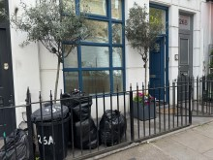 | 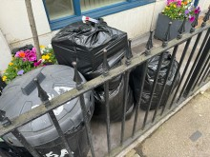 | 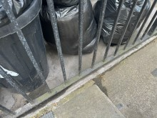
Front Exterior railings dusty | Front Exterior railings dusty | Front Exterior gate dusty
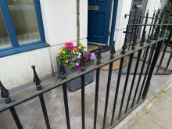 | 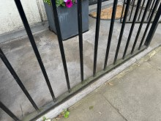 | 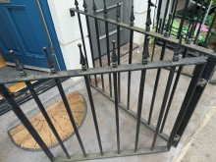
Front Exterior bags of rubbish | Front Exterior window sill & wall dusty | Front Exterior window sill & wall dusty
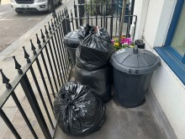 | 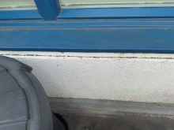 | 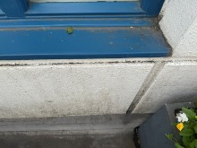
Front Door & Hallway | Front Door & Hallway door chips | Front Door & Hallway door dusty
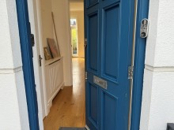 | 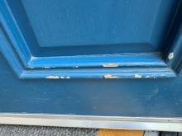 | 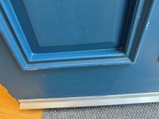

Front Door & Hallway door edge chips | Front Door & Hallway door edge chips | Front Door & Hallway doorbell replaced
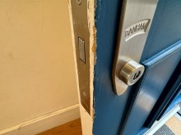 | 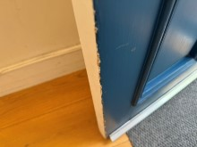 | 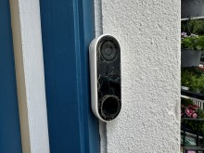
Front Door & Hallway threshold chipped | Front Door & Hallway | Front Door & Hallway door scratched
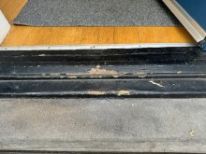 | 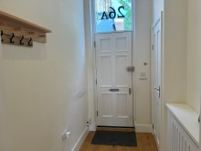 | 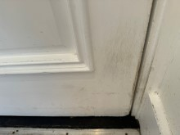

Front Door & Hallway door mail | Front Door & Hallway cable from doorbell | Front Door & Hallway cable & doorbell receiver box
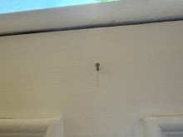 | 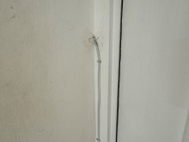 | 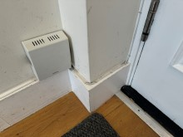
Front Door & Hallway skirting black scuffs | Front Door & Hallway skirting black scuffs | Front Door & Hallway skirting black scuffs
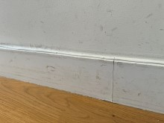 | 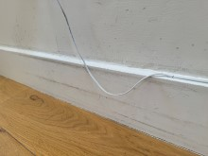 | 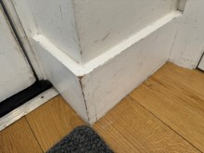

Front Door & Hallway wall flake & blu tac marks | Front Door & Hallway wall angle rubs | Front Door & Hallway wall screws
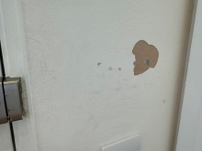 | 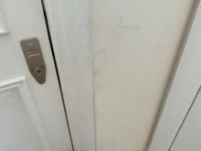 | 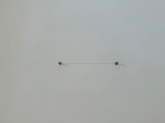
Front Door & Hallway wall heavy scuffs | Front Door & Hallway wall heavy scuffs | Front Door & Hallway wall heavy scuffs
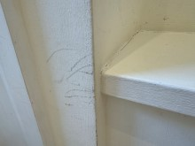 | 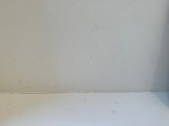 | 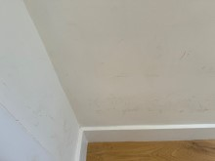

Front Door & Hallway wall heavy scuffs | Front Door & Hallway wall heavy scuffs | Front Door & Hallway wall heavy scuffs
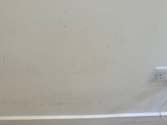 | 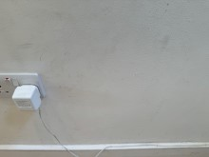 | 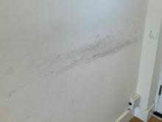
Front Door & Hallway wall heavy scuffs | Front Door & Hallway radiator cover ring mark & scuffs | Front Door & Hallway radiator cover scuffs
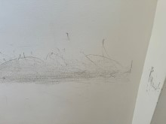 | 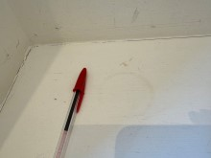 | 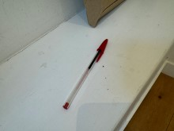

Front Door & Hallway radiator cover scuffs | Front Door & Hallway radiator cover scuffs | Front Door & Hallway door to Bedroom line of dents
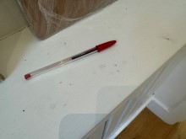 | 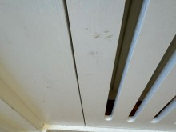 | 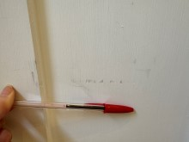
Front Door & Hallway door to Bedroom scuffs | Front Door & Hallway additional hook item to wall | Front Door & Hallway additional items to wall
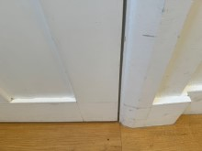 | 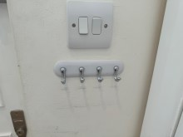 | 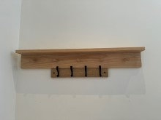

Reception
 | Item | Description | Check-in | Check-out
 | Doors/Windows
 | Doors | White painted panelled door  Brushed chrome lever handle/backing | Freshly painted, March 2022 | Black mid low level scuffs  Paint shaded
 | Door Frame | White painted | Freshly painted, March 2022
 | Reverse of Door | As exterior  Brushed chrome lever handle/backing | Freshly painted, March 2022 | Leading edge finger shaded
 | Door Frame | White painted | Freshly painted, March 2022 | Small edge chips
 | Threshold | None
 | Windows | Pair of clear double glazed windows to roof terrace  White painted frames  Brushed chrome lever handle/backing with integral lock  1 x key  4 x brushed chrome slide bolts  Black brushed draught strips to base of doors  Aluminium threshold  High level window above  White painted frame  Brushed metal ring pull | Panes intact  Light scratches to edges of glass  Clean  Freshly painted, March 2022  Aged  Shaded  Pane intact  Clean  Freshly painted, March 2022 | 1½” dent damage to RHS door paintwork  Glass smeary
 | Window Furnishings | White see-through roller blind operated by remote control  1 x Louvolite remote control | As new, March 2022  Working order | Not working during check-out  Blind stuck in up position  1 x remote control seen mounted to the wall, blue light flashes when buttons pushed, although blind not working

Reception
 | Item | Description | Check-in | Check-out
 | Décor
 | Flooring | Continuation of wooden planks from hallway | Good order  A few light long curved black scratches out from hallway  Several light old black scratches in front of roof terrace doors  Natural crack through 1 x board out from roof terrace  2 x curved black scrapes out from roof terrace  Couple of black scratches towards radiator by stairs | Some small furniture bruising marks to 2 x boards near centre
 | Skirting Boards | White painted | Freshly painted, March 2022 | Generally heavily black scuffed throughout
 | Walls | Pale cream painted | Freshly painted, March 2022 | 2 x small red marks  1 x nail with heavy shading under  Popped plaster board stud near TV socket  2 x TV brackets fitted as additional items with 2 x circular plaster holes nearby and heavy TV heat shading above fireplace  Some low level scribble marks  6” scrape opposite stairs  1 x nail LHS kitchen  3 x screws in rawlplugs  1 x further nail  General mid low level scuffs
 | Ceiling | White painted | Freshly painted, March 2022

Reception
 | Fixtures & Fittings
 | Item | Description | Check-in | Check-out
 | Lighting | 2 x wall mounted brushed brass twig style light fittings  2 x off-white semicircle shades  2 x ceiling mounted brushed brass black stem modern lights  4 x brushed brass frosted glass shades  6 x recessed shelf Tivoli light strips  4 x ceiling mounted spotlights to side of stairs | Working order  Working order  Working order  Working order
 | Heating | 3 x dark grey old fashion style radiators  Thermostat controls | All fittings intact  A few white paint marks | 1 x RHS cap not seen  Thick dust to bases, requires clean
 | Sockets and Switches | White plastic as supplied
 | Fixed Window | Fixed clear rectangular window with view down to stairs leading to bedroom 1 | Intact  Clean  A few light scratches to bottom corners
 | Inbuilt Shelves 1 | 2 x white painted shelves set in white painted frame  White painted ledge under | Freshly painted, March 2022 | Heavy dark grey/black heat shading high level  Appears to be candle type shading
 | Fireplace | Recessed black slate fireplace  Brushed stainless steel gas fire base operated by remote control  1 x small black fire remote | As new, March 2022  Not tested | Not tested  Remote control not seen
 | Inbuilt Shelves 2 | 2 x white painted shelves set in white painted surround  White painted ledge under  White plastic circular disc  2 x inbuilt white painted cupboard doors  Chrome white patterned knob handles  Interior:  White painted shelf  White plastic sockets as supplied | Freshly painted, March 2022  Freshly painted, March 2022  Freshly painted, March 2022 | Heavy dark grey/black heat shading to high level  Appears to be candle burn type marks and a black burn spot  Circle drill to LHS interior  General patchy shading

Reception
 | Item | Description | Check-in | Check-out
 | Thermostat | Wall mounted Honeywell Home thermostat | As new, March 2022
 | Loft Hatch | White painted ceiling loft hatch | Freshly painted, March 2022  Interior not inspected
 | Smoke Alarm | Ceiling mounted smoke alarm | Tested, sound emitted
ADDITIONAL ITEMS:
Pink foot stool (spot stains to top)
 |  |  |  | 2 x bags of miscellaneous items (contents not inspected)

Reception Photos
Reception | Reception | Reception door scuffs
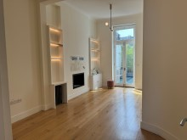 | 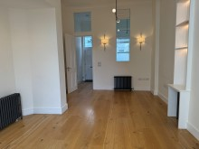 | 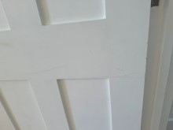
Reception door scuffs | Reception Terrace door dent damage | Reception blind control not working
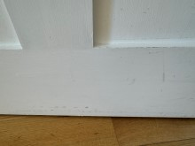 | 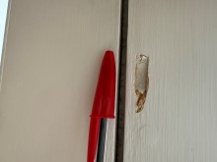 | 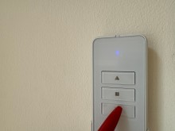

Reception blind in up position & not working | Reception floor furniture bruising | Reception floor furniture bruising
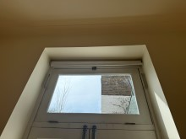 | 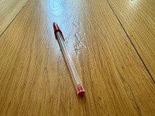 | 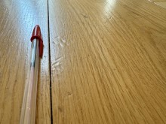
Reception wall scuffs | Reception wall red mark | Reception wall red mark
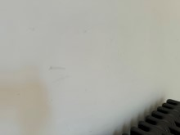 | 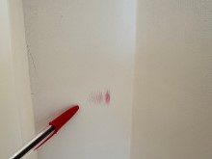 | 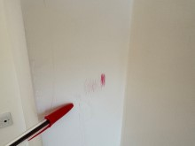

Reception wall nail | Reception wall shading | Reception wall popped stud
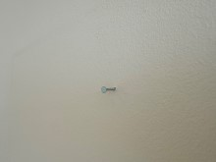 | 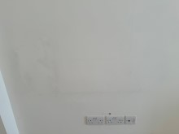 | 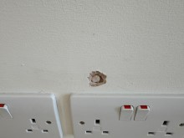
Reception wall TV brackets, 2 x holes & heavy shading | Reception wall 2 x holes – close up | Reception wall scribble marks
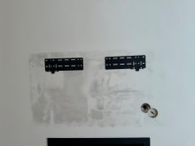 | 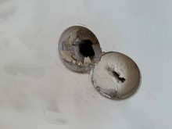 | 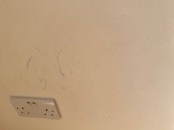

Reception wall scuffs & scrape | Reception wall scrape – close up | Reception wall nail
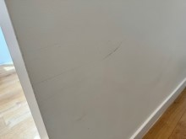 | 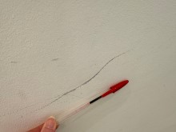 | 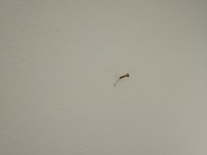
Reception wall screw & nail | Reception wall screws | Reception wall shaded marks
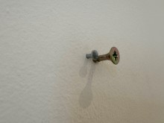 | 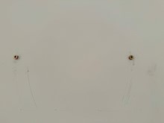 | 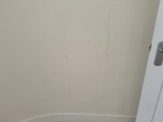

Reception skirting general heavy black scuffs | Reception skirting general heavy black scuffs | Reception skirting general heavy black scuffs
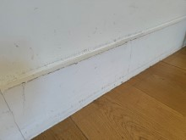 | 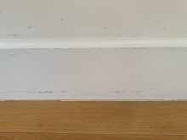 | 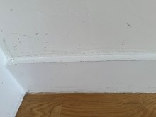
Reception skirting general heavy black scuffs | Reception skirting general heavy black scuffs | Reception skirting general heavy black scuffs
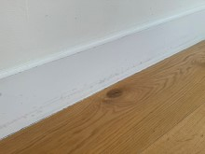 | 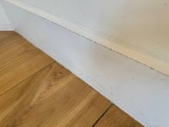 | 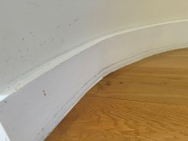

Reception skirting general heavy black scuffs | Reception skirting general heavy black scuffs | Reception radiator cap not seen
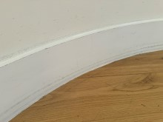 | 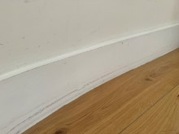 | 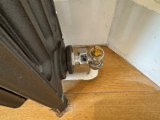
Reception radiators dust to base | Reception shelf heavy heat, candle type shading | Reception shelf heavy heat, candle type shading
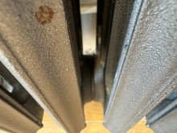 | 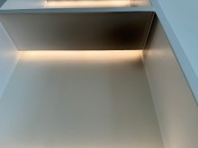 | 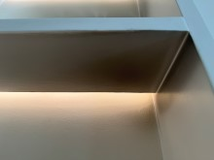

Reception shelf heavy heat, candle type shading | Reception shelf heavy heat, candle type shading | Reception shelf heavy heat, candle type shading
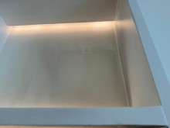 | 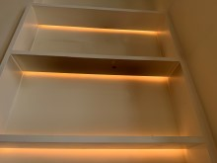 | 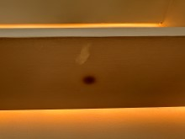
Reception shelf heavy heat, candle type shading | Reception shelf burn spot | Reception cupboard interior cable hole
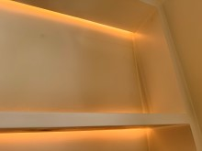 | 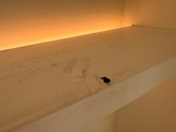 | 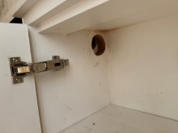

Reception additional stool item | Reception additional stool item stained | Reception additional bagged items
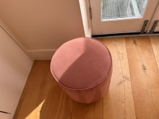 | 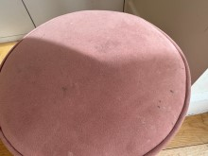 | 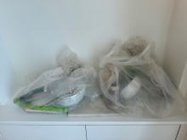

Kitchen
 | Item | Description | Check-in | Check-out
 | Doors/Windows
 | Doors | N/A
 | Door Frame | N/A
 | Reverse of Door | N/A
 | Door Frame | N/A
 | Threshold | N/A
 | Windows | Folding 3-part clear double glazed roof terrace doors  Grey metal frames  2 x locks  1 x key  1 x white handle  1 x grey metal handle  1 x black D-handle  2 x black plastic vents | Panes intact  Clean  Slight aged ingrained dust shading to frames particularly base of frames  Edges worn  Dull | Low level scuffs and frames appear dusty, requires clean
 | Window Furnishings | White plastic track  Single just above floor length grey linen net curtain | As new, March 2022 | Not freshly cleaned
 | Décor
 | Flooring | Continuation of wooden planks from reception | Good order  A few very minor scattered old black surface scratches  4” brown patch in front of sink  Natural defects  Small brown square mark by radiator | Gapping between boards forward of sink  Ants crawling on floor and crawling into reception area also
 | Skirting Boards | White painted | Freshly painted, March 2022 | Black scuffed under radiator

Kitchen
 | Item | Description | Check-in | Check-out
 | Walls | Part pale grey painted  Part pale grey ceramic rectangular tiles, off-white grout | Freshly painted, March 2022  As new, March 2022 | High level plaster chip LHS entry caused by unit door catches against wall  Grout shrinkage cracking at join with upstand
 | Ceiling | White painted | Freshly painted, March 2022
 | Fixtures & Fittings
 | Lighting | 6 x ceiling spotlights  2 x under unit Tivoli light strips | Working order  Working order
 | Heating | Modern grey vertical railed radiator  Thermostat control | As new, March 2022  Not tested  Couple of white paint splash marks | Thick dust to base and cobwebs behind, requires clean
 | Sockets and Switches | White plastic as supplied
 | Smoke Alarm | Ceiling mounted smoke alarm | Tested, sound emitted
 | Units | White laminate doors and drawers with brushed stainless steel handles  White laminate kickboards  2 x glass fronted wall units  4 x interior glass shelves  Interior sliding 3 x chrome shelves  Interior sliding chrome corner shelves | Support panel slight chipping to base RHS of dishwasher  Tiny surface chip to front of drawer LHS of oven  Wall unit angles slightly gapping  Painted over corner to wall unit angle RHS edge  Furthest RHS wall unit interior shelf laminate trim lifting to front and glue marks around door hinge  Intact  Intact | Lock symbol sticker to base unit door under sink and unable to open this door  Aycorn magnet release fitted to wall unit LHS panel, but not working to open door under sink  2 x laminate chips to corner base door leading edge  Interior shelf bracket has crumps, requires clean  Tiny chip to front of 1 x drawer  Lock symbol stickers to exterior drawers, although drawers open  RHS top middle and lower drawers have corner chips  RHS wall unit interior shelf laminate cracked and lifting
 | Boiler | Inbuilt Worcester boiler | Sticker removal mark to front | Plastic stick-on hook added to front

Kitchen
 | Item | Description | Check-in | Check-out
 | Worktop | White speckled granite work surfaces and matching upstands | Very good order  Appear new, March 2022 | 2 x tiny top front edge chips above dishwasher  1 x tiny top front edge chip LHS drawers  Upstand shrinkage cracking to top
 | Sink | Inbuilt brushed stainless steel Franke sink  Chrome mixer tap Grohe  Perforated plug | As new, March 2022
 | Ledge | White painted ledge behind sink | Freshly painted, March 2022
 | Appliances
 | Washing Machine | Inbuilt white A Plus washing machine | Appears to be in recent order, March 2022  Power tested  Light dark mould shading to door rubber inner | Water marks to door glass and dull mark within door rubber, requires further clean  Very dusty to low level behind kickboard, requires clean
 | Fridge Freezer | Inbuilt Bosch fridge freezer  Fridge:  Light and cover  4 x glass shelves, grey, white trim  Salad crisper  3 x door shelves  Freezer:  4 x drawers  4 x assorted ice cube trays  1 x ice block | Appears to be in recent order, March 2022  Power tested  Working order | Only 3 x glass shelves seen with white trim  Only 2 x door shelves seen  Possibly fridge freezer has been replaced with Similar Bosch model?
 | Dishwasher | Inbuilt Hotpoint dishwasher  2 x drawers  Cutlery basket | Good used order  Power tested  Door drops a little quickly on opening  Hinges slightly rusting | Replaced with Bosch dishwasher  Kickboard can detach easily underneath when closing door

Kitchen
 | Item | Description | Check-in | Check-out
 | Extractor | Stainless steel extractor/cooker hood  2 x lights and covers | Good used order  Power tested  Slight gapping at joins to hood although clear sealant to front join  Working order  Filters dented | 1 x light not working
 | Hob | Brushed stainless steel Smeg 5-ring gas hob  5 x gas rings  3 x black pan stands | As new, March 2022  Power tested | Some light burnt-on grease spots and a little tarnishing around the hob rings
 | Oven | Inbuilt brushed stainless steel IKEA Whirlpool oven  Interior light  Chrome shelf  Black grill pan and chrome rack | As new, March 2022  A few minor cleaning scratch marks to control panel  Working order | Smears to glass  Would benefit from further wipe  Further black grill pan seen to interior
 | Tumble Dryer | White John Lewis tumble dryer | As new, March 2022  Power tested | Controls dusty  Light old fluff within filter recess  Requires further clean
 | Furnishings
 | Corridy Folder | Corridy Property Management folder with useful information and instruction manuals
 | Chopping Board | Square frosted glass chopping board | Or possibly a spare glass tile | Not seen
 | Plunger | White handled black rubber plunger | Seen stored below sink | Possibly stored under sink, although unable to open this door

Kitchen
 | Item | Description | Check-in | Check-out
ADDITIONAL ITEMS:
Saucepans
Plastic jugs
White chopping board
Cable through wall and plugged-in to socket, appears to be for a security camera fitted to the outside area
Simple safe item (use unknown)

Kitchen Photos
Kitchen | Kitchen floorboards gapping | Kitchen wall flake & dent
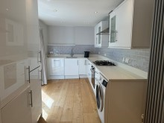 | 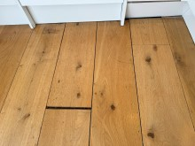 | 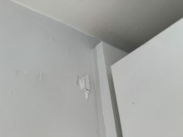
Kitchen wall grout gapping at join with upstand | Kitchen wall grout gapping at join with upstand | Kitchen boiler stick-on hook
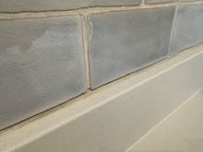 | 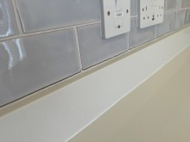 | 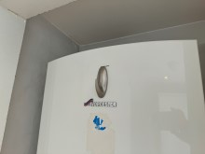

Kitchen unit child lock magnet opener | Kitchen unit door child lock sticker & door not opening | Kitchen unit drawers child lock stickers
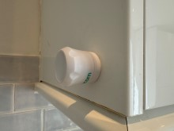 | 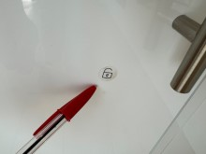 | 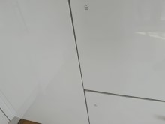
Kitchen unit door laminate edge chips | Kitchen unit interior crumbs to rails | Kitchen unit tiny surface chip
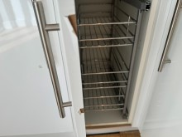 | 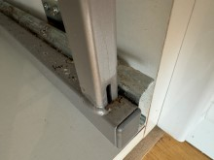 | 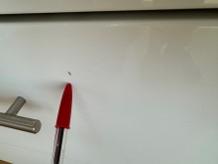

Kitchen unit drawer laminate edge chip | Kitchen unit drawer child lock fitted | Kitchen unit drawer child lock fitted
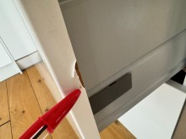 | 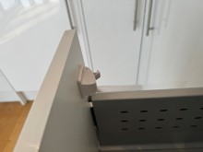 | 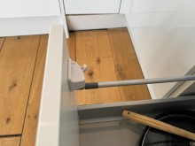
Kitchen unit drawer laminate edge chip | Kitchen unit drawer laminate edge chip | Kitchen unit interior shelf laminate crack & lifting
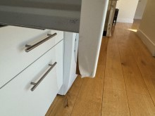 | 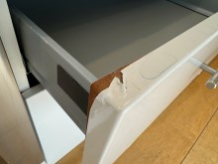 | 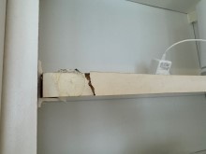

Kitchen worktop tiny edge chip | Kitchen worktop tiny edge chip | Kitchen worktop tiny edge chip
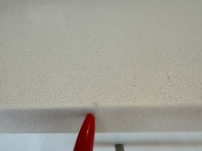 | 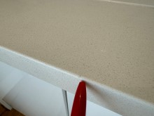 | 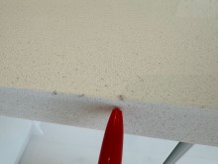
Kitchen | Kitchen | Kitchen
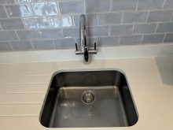 | 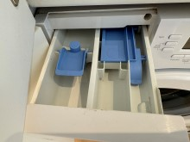 | 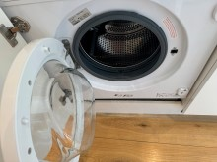

Kitchen | Kitchen thick dust under washing machine | Kitchen thick dust under washing machine
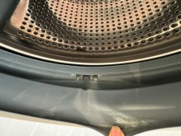 | 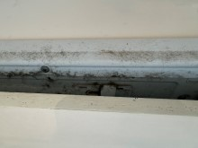 | 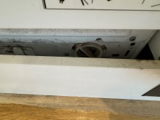
Kitchen | Kitchen | Kitchen
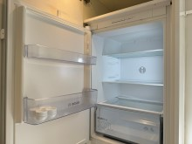 | 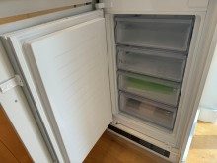 | 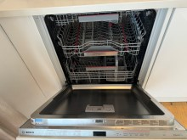

Kitchen kickboard detaches under dishwasher | Kitchen | Kitchen
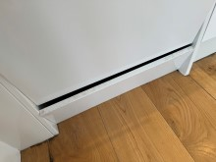 | 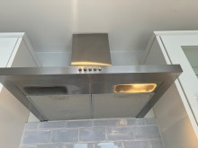 | 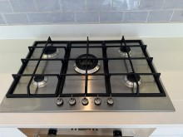
Kitchen hob ring burnt on spots & a little tarnished | Kitchen hob ring burnt on spots & a little tarnished | Kitchen hob ring burnt on spots & a little tarnished
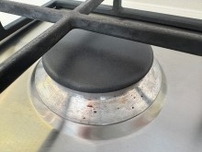 | 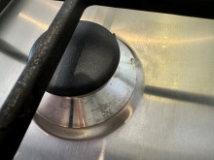 | 

Kitchen hob ring burnt on spots & a little tarnished | Kitchen hob ring burnt on spots & a little tarnished | Kitchen
 | 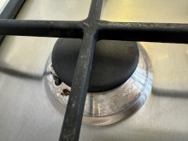 | 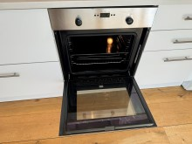
Kitchen | Kitchen | Kitchen tumble dryer fluff within filter recess
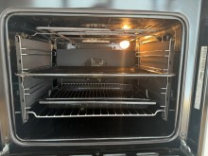 | 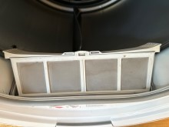 | 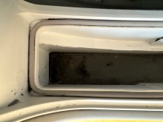

Kitchen additional items | Kitchen additional items | Kitchen additional items
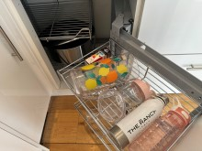 | 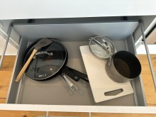 | 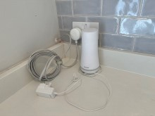

Terrace
 | Item | Description | Check-in | Check-out
 | Roof Terrace
 | Flooring | Toughened glass panels with black edges non-slip circular spots  Slim metal recess to side/by kitchen | Good used order  General light surface scratches  Recent dust and sand covering | White scale marks  Not cleaned very well
 | Walls | White painted | Freshly painted, March 2022  Painted over defects
 | Lighting | 2 x wall mounted modern metal circular light fittings  1 x wall mounted brushed stainless steel up and downlighter | Working order  Working order
 | Railings | Brushed stainless steel railings/handrail | Good used order  Dust and sand covering | Dusty, requires clean
 | Plants | Black rectangular planter with tall bamboo plants  3 x timber blocks under | Well established  Some leaves turning brown, appears to be dying  Recent leaf fall within planter
ADDITIONAL ITEMS:
Grey rattan seating and foot stool
Blue and wood table and 2 x chairs
2 x small plants within metal pots
Security camera fitted to the wall with cable entering into kitchen

Terrace Photos
Terrace | Terrace | Terrace glass floor panels scaled
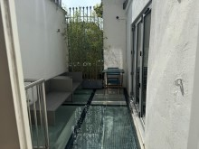 | 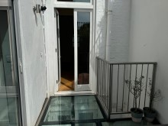 | 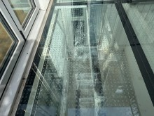
Terrace glass floor panels scaled | Terrace additional furniture | Terrace additional furniture
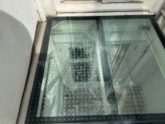 | 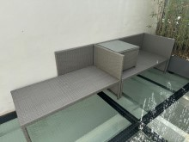 | 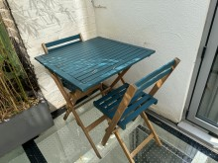

Terrace additional plants | Terrace additional camera to the wall | Terrace additional cable from camera
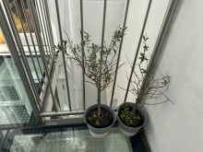 | 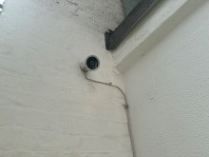 | 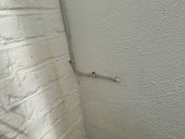

Stairs & Lower Hall
 | Item | Description | Check-in | Check-out
 | Doors/Windows
 | Doors | N/A
 | Door Frame | N/A
 | Reverse of Door | N/A
 | Door Frame | N/A
 | Threshold | N/A
 | Windows | N/A
 | Window Furnishings | N/A
 | Décor
 | Flooring | Grey Berber style carpet | As new, March 2022 | Some patchy grey marks, particularly on stairs, however carpet still wet/damp from professional cleaning  Re-inspect when dry
 | Skirting Boards | White painted | Freshly painted, March 2022 | Generally edge chipped on stairs  General black scuffs
 | Walls | Pale cream painted | Freshly painted, March 2022  Angle rubbed at bottom of stairs | 2 x damaged plaster chips at top of stairs from child gate fitting removal  Scribble marks at top of stairs  General mid low level scuffs  3 x plastic brackets and 2 x chips from child gate fitting removal in lower hall area by bedroom 1
 | Ceiling | White painted | Freshly painted, March 2022

Stairs & Lower Hall
 | Fixtures & Fittings
 | Item | Description | Check-in | Check-out
 | Lighting | 2 x ceiling spotlights  6 x skirting mounted spotlights on stairs | Working order  Working order
 | Heating | N/A
 | Sockets and Switches | White plastic as supplied
 | Ledge | White painted ledge at top of stairs | Freshly painted, March 2022
 | Glass Panel | Fitted toughened glass staircase panel  5 x stainless steel supports | As new, March 2022  A few paint marks to edges  Supports a little ingrained dust | Wood post fitted to side of glass for child gate to be attached thereon
 | Smoke Alarm | Ceiling mounted smoke alarm | Tested, sound emitted
 | Underfloor Heating | Wall mounted underfloor heating control | Not tested although screen display on and red light showing

Stairs & Lower Hall Photos
Stairs & Lower Hall | Stairs & Lower Hall additional post fitted to glass | Stairs & Lower Hall wall child gate fitting removal hole
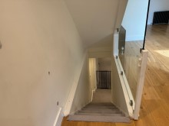 | 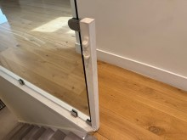 | 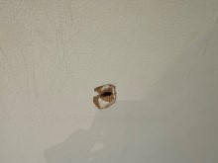
Stairs & Lower Hall wall child gate fitting removal hole & plastic bracket | Stairs & Lower Hall wall scribble marks at top of stairs | Stairs & Lower Hall
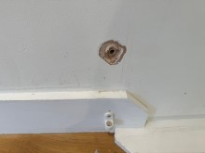 | 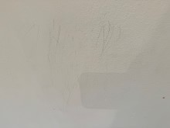 | 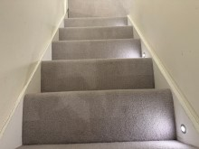

Stairs & Lower Hall | Stairs & Lower Hall skirting chipped & scuffed | Stairs & Lower Hall skirting chipped & scuffed
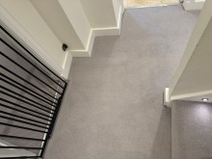 | 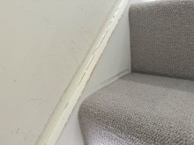 | 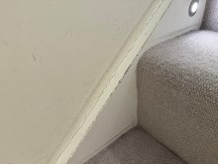
Stairs & Lower Hall skirting chips & wall scribble marks | Stairs & Lower Hall skirting chips & black scuffs | Stairs & Lower Hall skirting chips & black scuffs
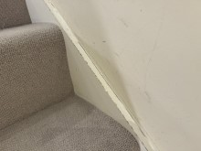 | 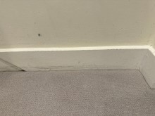 | 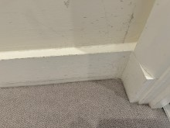

Stairs & Lower Hall skirting chips & black scuffs | Stairs & Lower Hall wall child gate fitting removal holes | Stairs & Lower Hall wall child gate plastic bracket
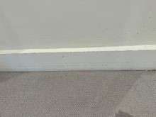 | 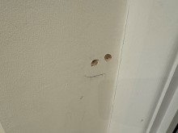 | 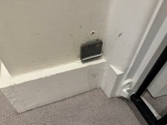
Stairs & Lower Hall wall child gate plastic bracket | Stairs & Lower Hall wall child gate plastic bracket | Stairs & Lower Hall wall shaded marks
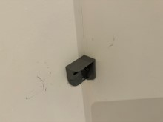 | 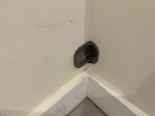 | 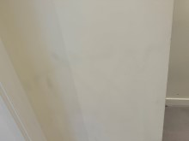

Bedroom 1
 | Item | Description | Check-in | Check-out
 | Doors/Windows
 | Doors | White painted panelled door  Brushed chrome lever handle/backing | Freshly painted, March 2022 | Plastic child lock fitting seen to exterior as additional item  Low level black scuffs
 | Door Frame | White painted | Freshly painted, March 2022 | Child gate fitted as an additional item
 | Reverse of Door | As exterior  Brushed chrome lever handle/backing | Freshly painted, March 2022 | Patchy shading  Low level black scuffs
 | Door Frame | White painted | Freshly painted, March 2022 | Light shrinkage cracking
 | Threshold | Aluminium | Good order
 | Windows | Large window on stairs, part clear double glazed, part frosted glazing  High level opening window  Metal ring pull  2 x metal levers  White painted frame  White painted sill  Reverse of fixed clear window through to reception | Panes intact, clean  Lower centre and RHS frosting edges a little rough  1” scratch defect to lower RHS frosting  Freshly painted, March 2022  Freshly painted, March 2022  Intact  Clean
 | Window Furnishings | White blackout roller blind operated by remote control  1 x Louvolite remote control | As new, March 2022  Working order | Not working  Black lead and plug seen extending from blind, although not plugged-in  Blind in up position  Remote control mounted to wall, blue light flashes when button pushed, although not working

Bedroom 1
 | Décor
 | Item | Description | Check-in | Check-out
 | Flooring | Continuation of grey Berber style carpet | As new, March 2022 | Still wet/damp from professional clean, however numerous various green, pink, black, brown spots and stains  Large 4’ yellow stained area which appears to be pet urine  Further scattered yellow stains and yellowing areas also appear to be pet urine  Some small moth type holes seen within large stain
 | Skirting Boards | White painted | Freshly painted, March 2022
 | Walls | Pale cream painted  Continuation of pale cream painted on stairs | Freshly painted, March 2022  Freshly painted, March 2022 | 2 x nails  Red ink type marks  Finger soiling  2 x further nails  10 x rawlplugs or screw holes  Small angle chips  Low level scuffs  Blue scribble marks at bottom of stairs  4 x fitting holes be from child gate fitting removal  Low level scuffs and finger marks
 | Ceiling | White painted | Freshly painted, March 2022
 | Fixtures & Fittings
 | Lighting | 4 x ceiling spotlights  4 x further ceiling spotlights above stairs  Ceiling mounted brushed brass black stem modern light fitting  3 x brushed brass frosted white glass shades | Working order  Working order  Working order
 | Heating | Dark grey tall vertical railed radiator  Thermostat control | Appears as new, March 2022  Not tested
Bedroom 1
 | Item | Description | Check-in | Check-out
 | Sockets and Switches | White plastic as supplied
 | Inbuilt Cupboard 1 | Wall mounted single white painted door (no handle)  Interior:  Décor white painted  Gas meter | Freshly painted, March 2022  Roughly cut to back panel behind gas meter pipe  Heavily paint marked
 | Underfloor Heating Control | Wall mounted underfloor heating control | Not tested  Screen display on, orange light showing | Sky router seen within cupboard
 | Under stairs Cupboard 1 | 2 x unvarnished wooden doors  Chrome handles  Interior:  Décor continuation  Part wood panelling  Carpet continuation  Aluminium threshold  Wall mounted fuse box and cover  Wall mounted circuit chart  Openreach double telephone socket  White and black USB CAT5E fitting  Double socket | Good order
 | Under stairs Cupboard 2 | Unvarnished wooden door with small chrome knob handle  Interior:  Décor continuation  Carpet continuation  Aluminium threshold | Good order  Handle paint marked  3 x metal shelf supports to LHS panel  Pencil markings between  No shelf fitted | Bottom door hinge a little loose

Bedroom 1
 | Item | Description | Check-in | Check-out
 | Staircase | Brown varnished wooden stairs leading to hallway  Unvarnished wooden staircase, newel posts, spindles and handrails  Wooden skirting boards | Appears freshly varnished, March 2022  Naturally patchy throughout varnish  A few light defects and indents under varnish  Good used order  Light aged shading, particularly to newel posts  A few small edge chips to newel posts  Screw hole to side of top newel post  A few white paint marks | Child gate fitted as an additional item at bottom of stairs
 | Door to Hallway | White painted panelled door  Brushed chrome lever handle/backing  White painted door frame | Freshly painted, March 2022  Freshly painted, March 2022
 | Inbuilt Cupboard 2 | Single white painted door  Clear Perspex chrome knob handle  Interior:  Décor white painted  Electric meter | Freshly painted, March 2022  A bit dusty to interior  Flue seen to LHS partly black taped to top

Bedroom 1
 | Item | Description | Check-in | Check-out
 | Inbuilt Wardrobe | 6 x white painted plain doors  Clear Perspex chrome knob handles  Interior:  LHS:  White painted décor  Strip light  4 x white painted shelves  Centre LHS:  White painted décor  Strip light  Chrome hanging rail  Centre:  White painted décor  2 x strip lights  8 x white painted shelves  RHS:  White painted décor  Strip light  White painted hat shelf  Chrome hanging rail | Freshly painted, March 2022  Working order  Working order  Working order  Working order | A few light scuffs by handles  White and grey shoe tidy rack seen to interior as an additional item
 | Furnishings
 | Loft pole | Wooden loft pole with brass hook end | Good order | Seen in hallway
ADDITIONAL ITEMS:
Security type camera fitted to the wall with conduit fitted over the cable

Bedroom 1 Photos
Bedroom One additional child gate | Bedroom One door additional plastic fitting | Bedroom One door black scuffs
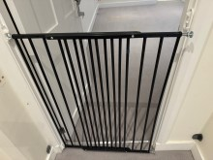 | 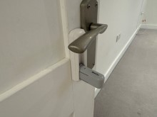 | 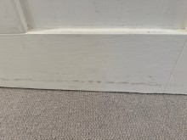
Bedroom One cable & plug from window blind | Bedroom One cable leading to window blind | Bedroom One blind remote not working
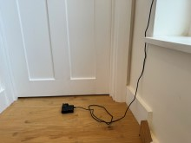 | 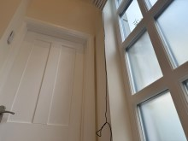 | 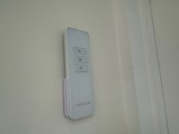
Bedroom One carpet | Bedroom One carpet stain | Bedroom One carpet stain
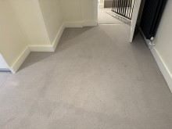 | 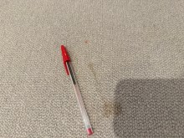 | 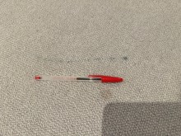
Bedroom One carpet stain | Bedroom One carpet stain | Bedroom One carpet stain
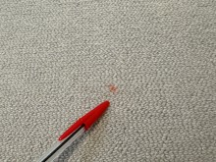 | 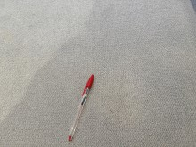 | 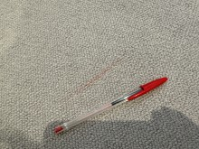

Bedroom One carpet stain | Bedroom One carpet large yellowed stained area | Bedroom One carpet large yellowed stained area
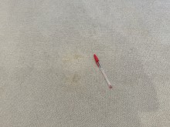 | 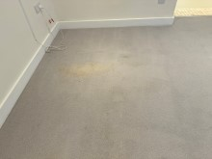 | 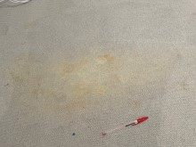
Bedroom One carpet stain | Bedroom One carpet stain | Bedroom One carpet stain
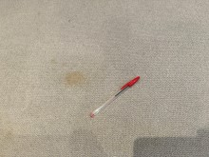 | 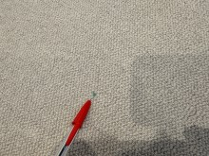 | 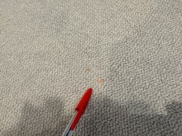

Bedroom One carpet stain | Bedroom One carpet yellowed stained appearance | Bedroom One carpet stain
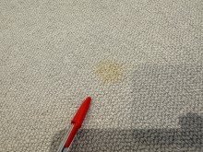 | 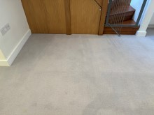 | 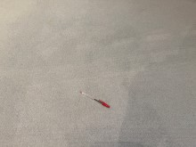
Bedroom One carpet moth holes | Bedroom One carpet moth holes within yellow stain | Bedroom One carpet yellow stained appearance
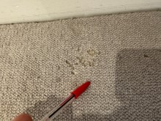 | 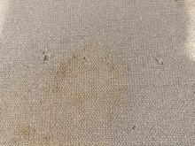 | 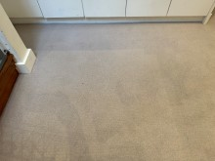

Bedroom One wall nail | Bedroom One wall nail | Bedroom One wall nail
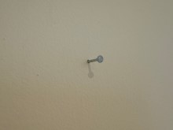 | 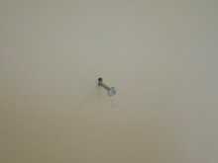 | 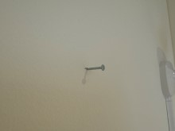
Bedroom One wall red marks | Bedroom One wall red marks | Bedroom One wall sticky mark
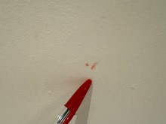 | 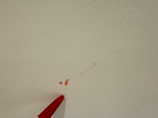 | 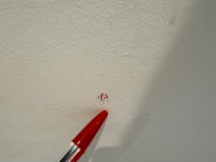

Bedroom One wall red marks | Bedroom One wall screw holes & rawl plugs | Bedroom One wall screw
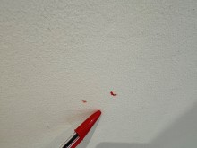 | 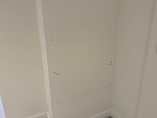 | 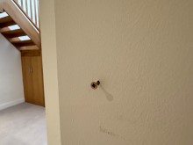
Bedroom One wall screws & rawl plug | Bedroom One wall rawl plugs | Bedroom One wall rawl plug
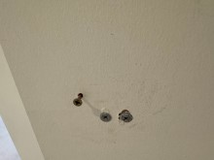 | 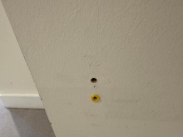 | 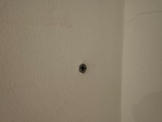

Bedroom One wall rawl plugs & screw hole | Bedroom One wall rawl plug & screw hole | Bedroom One wall blue scribble marks
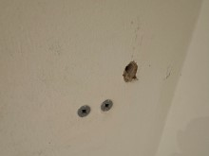 | 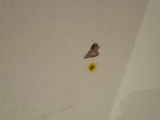 | 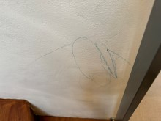
Bedroom One wall child gate fitting removal holes | Bedroom One wall child gate fitting removal holes | Bedroom One additional child gate
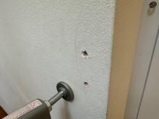 | 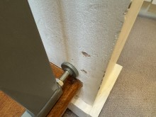 | 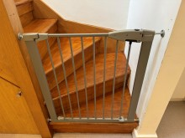

Bedroom One cupboard door hinge loose | Bedroom One additional camera fitted to the wall | Bedroom One additional camera conduit to the wall
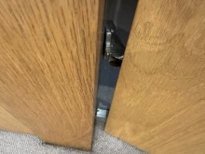 | 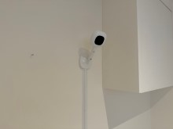 | 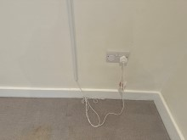

En-suite Shower Room
 | Item | Description | Check-in | Check-out
 | Doors/Windows
 | Doors | Green hued frosted glass door  Inset ring cut-out  Chrome hinges | Good order | A little patchy
 | Door Frame | N/A
 | Reverse of Door | As exterior | Good order
 | Door Frame | N/A
 | Threshold | Aluminium | Light scratches
 | Windows | N/A
 | Window Furnishings | N/A
 | Décor
 | Flooring | Pale cream/grey mottled small square ceramic tiles, cream grout  Part off-white silver mosaic tile effect linoleum  Part grey concrete within vault storage | Good used order  Shading to grouting  A little discolouration to grouting in places  As new, March 2022  Slightly rucked  As new, March 2022  Natural screed type line marks  Scattered white paint stains and paint marks | Significantly yellow stained
 | Skirting Boards | Part tiles as wall tiles  Part white painted | Good used order  Freshly painted, March 2022

En-Suite Shower Room
 | Item | Description | Check-in | Check-out
 | Walls | Part white painted  Part pale cream, grey mottled square tiles, off-white grout  Part plain cream rectangular ceramic tiles, grey grout | Freshly painted, March 2022  Painted over defects  White paint overspill marks to edges  Good used order  Grout appears refreshed, March 2022  Good used order  General gaps within grouting | 2 x white flakes or touch-ups LHS entry from bedroom  Red scribble mark low level LHS entry  Blue liquid or ink type stain marks either side of shower area entry
 | Ceiling | White painted | Freshly painted, March 2022 | A bit patchy and spotting within shower area
 | Fixtures & Fittings
 | Lighting | 4 x ceiling spotlights  2 x wall mounted brushed stainless steel down lighters  4 x small spotlights below slatted shelf  2 x wall mounted frosted plastic shade lights with vault area | Working order  Working order  Not working  Working order | Not working as at start of tenancy
 | Heating | Chrome ladder style radiator | Fittings intact  Rust colour stain to lower rail  Some tiny rust marks to side rails  Not tested
 | Sockets and Switches | White plastic fused switches as supplied
 | Mirror | Wall mounted rectangular mirror | As new, March 2022
 | Basin | Wall mounted small white basin  Chrome mixer tap  Chrome push release plug | As new, March 2022
 | Vanity Cupboard | White laminate door with chrome handle  Interior:  White laminate shelf | As new, March 2022

En-Suite Shower Room
 | Item | Description | Check-in | Check-out
 | WC | White WC  White plastic seat and lid  Chrome double push flush | Very good order  Sealant as new, March 2022
 | Vent | Wall mounted white plastic vent | Edge paint marked
 | WC Roll Holder | Wall mounted chrome WC roll holder | As new, March 2022
 | Vent | Ceiling mounted white vent extractor | Working order
 | Shower Area | Floor mounted square metal plug surround  Wall mounted chrome double shower controls Grohe  Chrome showerhead and hose  Wall mounted chrome shower rail with head holder  Wall mounted chrome corner shower tidy | Aged, dull, scratches  As new, March 2022  As new, March 2022  As new, March 2022  Odd paint marks  As new, March 2022
 | Shelf | Fitted white painted timber slatted shelf | Freshly painted, March 2022 | Candle wax stains near the LHS light fitting
 | Vault Storage Area LHS & RHS | Continuation of white painted  Pink plastic box with assorted paint pots and brushes  2 x boxes of spare tiles  Wall mounted vent extractor  Spare piece of triangular shaped timber | Freshly painted, March 2022  Working order  Heavy black circular stains and further black sticky stained marks  Paint marks | LHS area has blue, yellow and pink ink type marks or crayon marks to the walls  Slight mildew spotting by the extractor vent
ADDITIONAL ITEMS:
Broom
Mop
Pieces of timber

En-Suite Shower Room Photos
En-Suite Shower Room | En-Suite Shower Room | En-Suite Shower Room
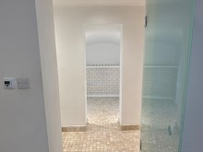 | 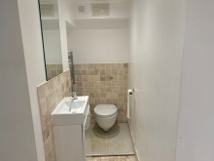 | 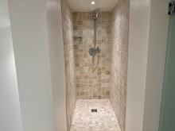
En-Suite Shower Room floor yellow stained by WC | En-Suite Shower Room wall flake | En-Suite Shower Room wall flake
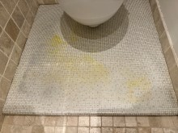 | 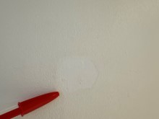 | 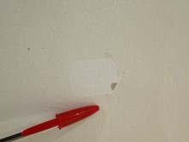
En-Suite Shower Room wall red scribble mark | En-Suite Shower Room wall blue liquid type marks | En-Suite Shower Room wall blue liquid type marks
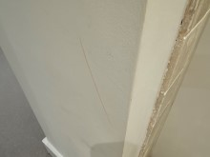 | 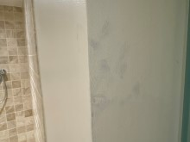 | 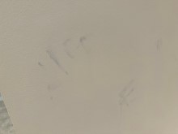
En-Suite Shower Room wall blue liquid type marks | En-Suite Shower Room ledge wax stained | En-Suite Shower Room
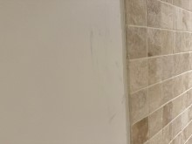 | 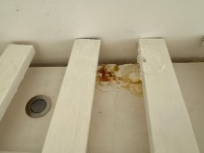 | 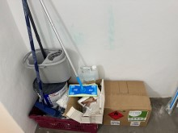

En-Suite Shower Room wall blue stains | En-Suite Shower Room wall blue & yellow stains | En-Suite Shower Room wall blue stains
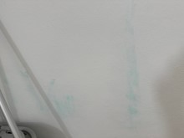 | 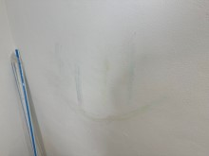 | 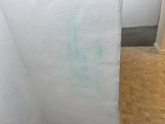
En-Suite Shower Room wall mildew by extractor vent | En-Suite Shower Room | En-Suite Shower Room additional timber
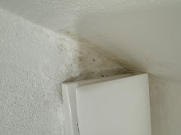 | 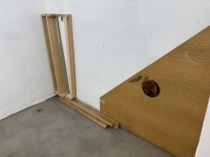 | 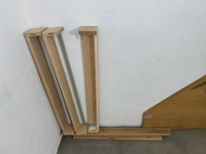

Bathroom
 | Item | Description | Check-in | Check-out
 | Doors/Windows
 | Doors | White painted panelled door  Brushed chrome lever handle/backing | Freshly painted, March 2022
 | Door Frame | White painted | Freshly painted, March 2022
 | Reverse of Door | As exterior  Brushed chrome lever handle/backing  Integral twist lock | Freshly painted, March 2022
 | Door Frame | White painted | Freshly painted, March 2022 | Shrinkage cracking
 | Threshold | Aluminium | Light wear to edge
 | Windows | N/A
 | Window Furnishings | N/A
 | Décor
 | Flooring | Cream travertine style tiles  Off-white grout | Good used order  2 x hairline cracked tiles on entrance  Third tile hairline cracked LHS of bath panel and filler mark beside the crack  3 x grey score line marks below vanity drawers | Raised box-in area by bath panel dusty underneath basket, requires clean
 | Skirting Boards | White painted | Freshly painted, March 2022  Some grey scuffs below bath panel | General scattered top edge chips and wear
 | Walls | Part white painted  Part pale grey mottled rectangular tiles, off-white grout | Freshly painted, March 2022  As new, March 2022 | 2” filler mark by WC roll holder  White plastic stick-on hook  Scattered scuffs  Heavy plaster dent damage caused by door handle hitting against wall
 | Ceiling | White painted | Freshly painted, March 2022

Bathroom
 | Item | Description | Check-in | Check-out
 | Fixtures & Fittings
 | Lighting | 5 x ceiling spotlights | Working order
 | Heating | Wall mounted chrome ladder style radiator | Fittings intact  Slight patchy dull chemical smears throughout rails
 | Sockets and Switches | White plastic shaver socket | Intact
 | WC | White WC  White plastic soft close seat and lid  Chrome double flush Geberit | Good used order  Hinges heavily rusted and tarnished  Underside seat yellow discoloured
 | Ledge | Ledge/boxing LHS of WC tiled as floors | Good used order
 | WC Brush and Holder | White plastic WC brush and holder | Used order | Not seen
 | WC Roll Holder | Wall mounted chrome WC roll holder | As new, March 2022
 | Basin | White basin with integral white ceramic basin surround  Chrome mixer tap  Chrome push release plug | As new, March 2022  White paint spot to front RHS surround edge | Chrome mixer tap heavily chemically damaged
 | Vanity Drawer | 2 x pale cream glass fronted vanity unit drawers with integral handles | Appears as new, March 2022
 | Ledge | White granite raised ledge surface RHS of basin | Appears as new, March 2022
 | Cabinet | Wall mounted cabinet  3 x mirrored doors with small pulls  Chrome frosted strip light above  Interior:  6 x glass shelves | Appears as new, March 2022  Working order
 | Ledge 2 | Ledge/boxing LHS of bath tiled as floors | Good used order

Bathroom
 | Item | Description | Check-in | Check-out
 | Bath | White bath  Chrome pop-up plug and control/spout  Chrome showerhead and hose  Wall mounted chrome shower rail and head holder  Wall mounted chrome double shower mixer control  Chrome framed clear glass shower screen, fixed glass panel to side  White painted bath panel | Good order  Circular surface chip to bath enamel below spout/pop-up control  Sealant fresh, March 2022  Fittings appears as new, March 2022 | Pop up plug not working very well  Minor mould marks to sealant corners at shower end  Chrome double shower mixer control backing has some chemical smear marks  White bath panel generally patchy  Slight warping to top edge of bath panel and 3 x screw covers not seen
 | Ledge 3 | White Corian ledge to side of bath | As new, March 2022
 | Vent | Ceiling mounted vent extractor | Working order
ADDITIONAL ITEMS:
1 x wicker basket box

Bathroom Photos
Bathroom | Bathroom | Bathroom wall filler mark
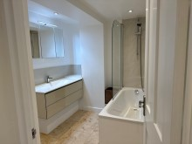 | 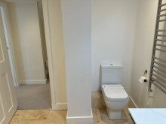 | 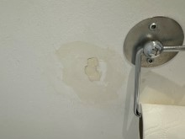
Bathroom wall stick-on hook | Bathroom wall dent damage behind door handle | Bathroom wall dent damage – close up
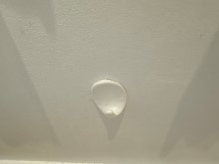 | 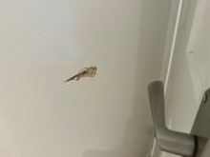 | 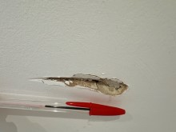
Bathroom skirting chips | Bathroom skirting black rubs | Bathroom skirting chips
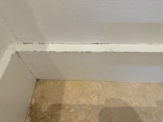 | 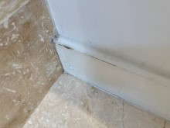 | 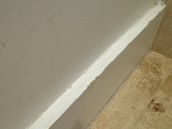
Bathroom skirting chips | Bathroom basin tap chemically damaged | Bathroom basin tap chemically damaged
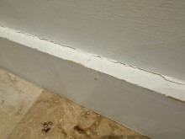 | 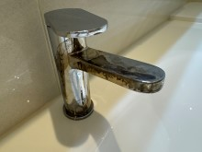 | 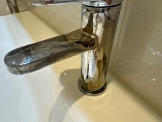

Bathroom bath control backing chemical marks | Bathroom bath control backing chemical marks | Bathroom bath panel patchy
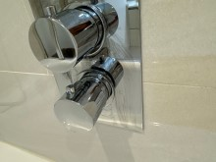 | 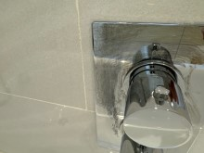 | 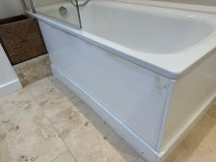

Bedroom 2
 | Item | Description | Check-in | Check-out
 | Doors/Windows
 | Doors | White painted panelled door  Brushed chrome lever handle/backing | Freshly painted, March 2022 | Low level black scuff and scratches
 | Door Frame | White painted | Freshly painted, March 2022
 | Reverse of Door | As exterior  Brushed chrome lever handle/backing | Freshly painted, March 2022
 | Door Frame | White painted | Freshly painted, March 2022
 | Threshold | Aluminium | Good order
 | Windows | Clear double glazed patio doors  White painted frame  Brushed chrome lever handle/backing with integral lock  1 x key  1 x small key  3 x white Yale locks  White window lever handle with integral lock  2 x keys  Metal closer arm  Dark brown varnished wooden threshold  RHS doors:  3-part folding clear double glazed doors  Grey frames  Grey lever handle with integral lock  1 x key  Further grey handle  Black D-handle | Panes intact, clean  Freshly painted, March 2022  Freshly varnished, March 2022  Panes intact, clean  Couple of light smears to glass low level  Good used order  Ingrained dust within frame corners

Bedroom 2
 | Item | Description | Check-in | Check-out
 | Window Furnishings | 2 x white curtain tracks  3 x grey just above floor length blackout lined curtains | As new, March 2022  As new, March 2022 | 2 x curtain hooks appear to be missing  Not freshly cleaned
 | Décor
 | Flooring | Continuation of grey Berber style carpet | As new, March 2022 | Carpet still wet/damp from professional cleaning with patchy appearance  Appears to have yellow stained areas, particularly out from wardrobe and LHS patio doors to left of entry, re-inspect when dry  A few small moth type holes
 | Skirting Boards | White painted | Freshly painted, March 2022
 | Walls | Pale cream painted | Freshly painted, March 2022 | 4 x screws  2 x pins  1 x rawlplug  Low level damp LHS area left of patio doors  Low level damp in recess RHS of patio doors
 | Ceiling | White painted | Freshly painted, March 2022
 | Fixtures & Fittings
 | Lighting | 12 x ceiling spotlights | Working order
 | Heating | Grey industrial style radiator  Thermostat control  Further modern tall dark grey radiator  Thermostat control | Appears as new, March 2022  Not tested  Appears as new, March 2022  Not tested  2 x screw drill holes to wall behind above lower brackets
 | Sockets and Switches | White plastic as supplied

Bedroom 2
 | Item | Description | Check-in | Check-out
 | Inbuilt Wardrobe | 4 x white painted plain doors with clear Perspex chrome knob handles  Interior:  LHS:  White painted décor  Strip light  4 x white painted shelves  RHS:  White painted décor  White painted hat shelf  Chrome hanging rail  Strip light | Freshly painted, March 2022  Working order  Working order
 | Vent | Wall mounted Vent-Axia extractor | Working order | Possibly not working  Or very quiet?
 | Inbuilt Cupboard | White painted long door  Brushed chrome knob handle/backing  Interior:  Décor continuation  Carpet continuation  Wall mounted black SLX fitting with white cables  Sockets as supplied  Red stopcock  White plastic light switch  Strip light | Freshly painted, March 2022  Painted over defects  Large and 4 x small drill holes RHS of socket  Paint marked  Working order
ADDITIONAL ITEMS:
White railed shelf unit
Double bed
Double mattress (label side stained)
Double mattress protector
2 x bedside tables
Large chest of drawers (black mark to top)

Bedroom 2 Photos
Bedroom Two | Bedroom Two | Bedroom Two door black scuffs
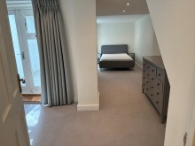 | 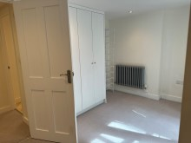 | 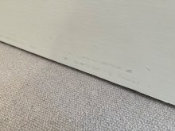
Bedroom Two curtain hooks detached from track | Bedroom Two curtain hooks detached from track | Bedroom Two carpet appears yellowed
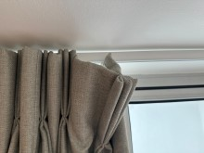 | 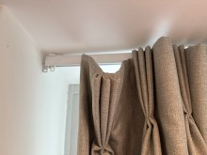 | 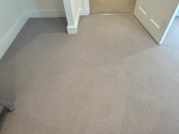
Bedroom Two carpet spears yellowed | Bedroom Two carpet yellow stains | Bedroom Two carpet yellow stains
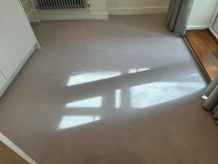 | 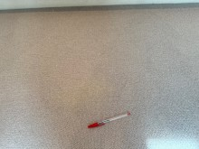 | 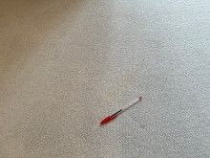
Bedroom Two carpet yellow stains | Bedroom Two carpet wall screw | Bedroom Two carpet wall appears damp by sockets
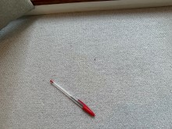 | 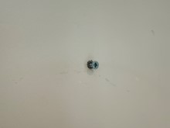 | 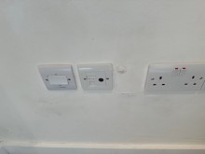

Bedroom Two carpet wall damp by Patio door | Bedroom Two carpet wall screws | Bedroom Two carpet wall screw
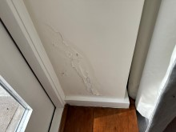 | 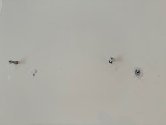 | 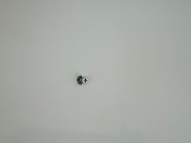
Bedroom Two carpet additional items | Bedroom Two carpet additional items | Bedroom Two carpet additional items
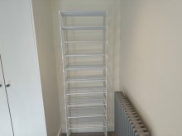 | 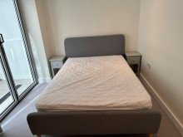 | 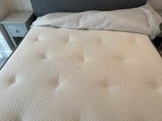

Bedroom Two carpet additional mattress is stained | Bedroom Two carpet additional items | Bedroom Two carpet additional drawer mark to top
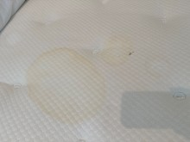 | 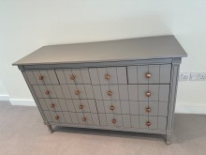 | 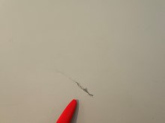

Patio
 | Item | Description | Check-in | Check-out
 | Patio
 | Flooring | Grey square concrete tiles  White grout  Tiled square access panel  Black rectangular drain | Good used order  Dusty and recent sand covering  Dusty  Sand covering  Interior not inspected  Ingrained dust  Paint marks
 | Walls | White painted | Freshly painted, March 2022  Painted over defects  Dusty and cobwebs | Dusty and cobwebs as noted on inventory at start of tenancy
 | Ceiling | Underside of glass panels to roof terrace  White painted metal supports | Glass dusty and smeary  Freshly painted, March 2022  Some cobwebs | White scale marks seen, requires clean
 | Tap | Wall mounted garden tap with yellow nozzle | Paint marked
 | Keys | 2 x black T-bar keys | Tied with blue cord underneath pipework
ADDITIONAL ITEMS:
Deck chair

Patio Photos
Patio additional deck chair to far end | Patio | Patio glass panels above white scaled
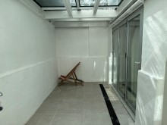 | 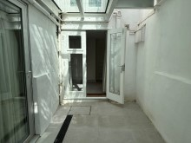 | 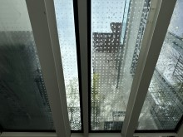

Disclaimer
Important Information to be read by all involved parties
This inventory provides a fair and accurate record of the contents and condition of the property as well as the property’s internal condition. The sole responsibility lies with the tenant, landlord or any agent working on the landlord’s behalf to fully agree with this report and sign it to confirm this. This inventory is for making comparisons at the end of the tenancy agreement that it relates to. This inventory is prepared “as seen snapshot” of the property and its contents at the time of the inspection and is compiled as a fair and accurate record of the property’s internal condition and its contents and should not be used as an accurate description of each and every piece of furniture and equipment, or as a structural survey report. We do not comment on any structural defects. Therefore as the Inventory Clerk preparing this inventory is not an expert on fabrics, woods, materials, antiques, etc., nor is a qualified surveyor or valuer, they are not required to state whether an item is antique, made of precious metals, of unique origin, or whether it is new despite the appearance being obviously so. No attempt has been made to value the property or any of its contents. We will fully check blinds and curtains to ensure they are secure and fully functioning. We will also record if tie backs are present for long chords & we will accept no liability for any blinds or curtains that are found to have issues after our inspection. We must be told if any items within the property are brand new so that this can be stated at the time the report is carried out. Please be advised that the items left in lofts, cellars or in locked rooms or cupboards, garages and sheds that have not been noted in the inventory are the sole responsibility of the landlord. We will need instruction to check areas such as lofts, cellars, basements, front and back gardens, garages and sheds. The moving of any heavy furniture items or appliances will not be undertaken and therefore some observations may be restricted where such items restrict full view. We will not lift any mattresses or be able to view in any way the undersides of such; this could miss any damage present. Our clerks will attempt to note all or any present odours; there sense of smells will alter and so the accuracy of this is not something we can be held accountable for. Where inventories are completed with tenants in situ and it is deemed difficult for clerks to differentiate between that belonging to the landlord or tenant, then the report may contain inaccuracies for which the clerk cannot be held responsible. Any images/photographs taken may not reflect accurately the condition or damage as stated in our report as lighting and any other such conditions can greatly affect these images. Please use these images in connection with the written report. It is strongly advised that the receipt. This report should be thoroughly checked. Please note clerk cannot be held responsible for any errors, omissions or issues you may feel are contained within our reports. It is very important that any notes required within the report are mentioned to the clerk at the time of the report being complied. We cannot be held responsible for any issues or omissions.
When a check out report is made all comparisons will be made at the time between how the property has been left with the original inventory report taken at the start of the tenancy. Meters will be checked where seen and where access is made possible. We will attempt to note the location of any visible stop cocks/safety values. We cannot be held responsible for any discrepancies or issues with our readings. The utility companies must be asked to check any meter readings given or required. At the check-out all items and goods not belonging to the property/tenancy must have been removed and cleaning must have been fully completed. The property must be left in the condition it was found on the day the tenancy started.
Safety Disclaimer
The Inventory relates only to the furniture, furnishings and all landlord’s equipment and contents in the property. It is no guarantee of, or safety of, any such equipment or contents, merely a record that such items exist in the property at the date of the inventory and the superficial condition of the items. None of the electrical boilers, gas fires, hobs, water supplies, fire alarms, radiators or gas appliances have been checked for working order; this is not part of our standard report. Should any of the electrical appliances, switches and sockets or anything else mentioned be tested for power or working order it is absolutely no indication of its safety in any way. We are just stating the item or fixture is present, and its condition, at the time of this report. Blinds and cord safety 1st October 2014; all binds etc. must have safe pull controls/cords. We will not be held liable for any cords/controls that do not comply, whether we have noted this or not. Overlong cords can cause a health and safety issue. We do not in any circumstance look for signs of Legionella and will not in any way be held liable for such within any premises we carry out any such report on.
Furniture & Furnishings (Fire) (Safety) Regulations 1988 as amended 1993
Relevant furniture and furnishings, which have the appropriate label complying with the above regulations, can be indicated on the inventory as “fire resistant”, but is not considered a part of our services. Where we see an F&F label this does not mean that we are stating in any way that this item is suitable and complies.
PLEASE NOTE:
All furniture needs to be returned to it is original position as noted on Check-in inventory report, failure to do so may result in the item being listed as not seen and result in the tenant being charged for the missing item.
Fireguards
Where there are loose fireguards, not part of a heater, gas or electric fire this may be indicated on the inventory.
Smoke Alarm/Detectors& Carbon Monoxide Alarm/Detectors
It is the tenant’s responsibility, or any other party such as the landlords or their agent, to inspect any smoke /alarm detector fitted in the property at regular intervals to ensure they are in full working order as per the manufacturer’s instructions. We are not responsible to check these or if we have checked the power or working order of such equipment, this does not mean in any way it is still functioning or working effectively after our checks.
The Smoke and Carbon Monoxide Alarm England regulations 2015
Smoke alarms/detectors and carbon monoxide alarms/detectors are tested for power only in compliance with The Smoke and Carbon Monoxide Alarm England Regulations 2015.

This law is under The Smoke and Carbon Monoxide Alarm England regulations 2015. Under this law you must provide a working and tested smoke alarm/detector on every floor of the property and a carbon monoxide alarm/detector in every room that contains a solid fuel combustion appliance. Power and/or functionality tests must also be carried out on every new tenancy by law, via the Tenant / Instructing Principle / Landlord. As stated, we accept no responsibility whatsoever for any testing of, recording of missing or present and/or working order of any such smoke alarm/detectors and or carbon monoxide detectors within a property following a report or visit from our clerks. Where smoke alarms and CO Detectors are tested this is for power only and should not be taken to mean that the alarms are in full working order. No responsibility is taken for any damage or malfunction occurring during the testing of such alarms.

END OF TENANCY INFORMATION
***IMPORTANT - TO BE READ***
Please read all these notes fully as they state what needs to happen for a smooth check out process as well as what our clerks are trained to look for and note within a property.
FULL CLEAN: This must be very thorough. Floors, walls, sanitary ware, windows, woodwork, all kitchen units, all rooms, ovens, cooker hoods, fridges and freezers, extractor fans, wardrobes, any linens and beddings. We will be inspecting all furnishings and appliances. You are required to return the property the same way as noted in the original inventory report; most managing agents and landlords will have to instruct professional cleaners if this is not done, this cost will be from your deposit.
FLOORING: Needs to be fully cleaned. If there are any stains or marks, the flooring should be professionally cleaned by a regulated cleaning company. You can be charged for stains or marks of any kind. If a flooring is badly damaged you may be charged for its entire replacement.
UTENSILS: This will all be inspected for damage and soiling. It should all be thoroughly cleaned and in the same place as at the beginning of the tenancy or it could be noted as missing.
BEDROOM FURNISHINGS: All beds and their respective mattresses and bases will be thoroughly examined for stains and damage. Charges would be made if there are any issues not noted on your original report. If any sheets, duvets etc. were provided these will need to be cleaned and pressed. All linen should be placed on top of the respective bed so that the bed can be fully inspected.
ALL FURNISHINGS: These should be in a similar condition as provided and will be fully inspected. You should take all means necessary to protect all furnishings during your tenancy, as damage can result in deductions from your deposit. This includes all marks, stains, scratches, loose joins, polish finishes, burns, ring marks, soiling or discolouration etc. All furnishings and any equipment must be returned to its original position or it may not be noted as present in the check out and may incur a charge for the missing item.
GENERAL DECORATION: Any excessive damage, marking, scratches etc. can be deemed as beyond fair wear & tear. This can include nails, screws and hooks in walls, furniture marks etc. Please always gain written permission from all relevant parties prior to making alterations or changes of any kind.
DRAINS: These should be tested and running free with no blockages.
LIGHTBULBS: These should all be replaced and fully working.
KEYS: All keys from the beginning of the tenancy must be available, ready and clearly marked, including any cut during the tenancy. Lost keys can result in a charge for the replacement of the property’s locks.
GARDENS: The front and back gardens will need to be maintained throughout your tenancy. Lawn cutting, weeding, maintaining flower beds and any other seasonal works required. We would suggest you liaise with your landlord and or managing agent regarding this and any specific needs.
RUBBISH: Any and all rubbish or excess rubbish should be completely removed from inside and outside the property, as organising this will incur a cost for removal.
ODOURS: Any odours present in the property must be eradicated prior to the check out. These often include cooking smells, food smells, the smell of smoking, sewage smells, damp smells or the smell of any pets.

All of the above useful information will vary and depend upon discrepancies, including how the property was at the beginning of any tenancy and what was agreed.

Signatures
By signing below you confirm that you have received the keys to the property. You will have 7 days upon receipt to register any queries with our office, otherwise it is understood you are in agreement with the content of the report regardless of the presence of signatures. If the property is rented to multiple tenants, one tenant signature or one tenant receiving the report denotes approval of all tenants. We the tenants are satisfied of the presence and power testing of both smoke alarms/detectors on all floors within the property and carbon monoxide alarms/detectors where a solid fuel burning combustion appliance is present.
Tenant
Name: Date:

Signature:

Landlord/Verifier
Name: Date:

Signature:

